**Environment & Social Management Report (ESMP)**

**Addendum**

**09.06.2017**

Efficient & Sustainable City Bus Services

GEF-5 (P132418)

MIRA BHAINDER MUNICIPAL TRANSPORT UNDERTAKING

GHODBUNDAR DEPOT CONSTRCTION

**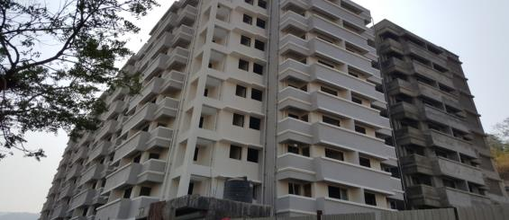**

**Contents**

[**A. Introduction:** 4](#_Toc485495208)

[**B. Justification for Addendum of ESMP:** 4](#_Toc485495209)

[**C. Brief of BSUP Scheme and Relocation Plan of slum dwellers:** 4](#_Toc485495210)

[**D. Land Acquisition & Impacts:** 7](#_Toc485495211)

[**E. Lay out Plan of Ghodbundar Depot Site including BSUP Transit Camp :** 8](#_Toc485495212)

[**F. Socio Economic Profile of affected Slum Dwellers:-** 9](#_Toc485495213)

[**a.** **Population Composition** 9](#_Toc485495214)

[**b.** **Demographic Profile of affected slum dwellers:** 10](#_Toc485495215)

[**c.** **Income & Occupational Pattern:** 10](#_Toc485495216)

[**G. Consultations & Participations:** 10](#_Toc485495217)

[**H. Policy of legal Framework:** 12](#_Toc485495218)

[**(I).The Right to Fair Compensation and Transparency in Land Acquisition, Rehabilitation and Resettlement Act, 2013** 12](#_Toc485495219)

[**(II). The World Bank’s Safeguard Policies** 13](#_Toc485495220)

[**(III).Slum Areas of Maharashtra (Improvement, Clearance & Redevelopment) Act, 2003** 14](#_Toc485495221)

[**(IV). Entitlement Framework for ESCBSP** 15](#_Toc485495222)

[**I. Income Restoration:** 16](#_Toc485495223)

[**J. Grievance Redressal Mechanism:** 16](#_Toc485495224)

[**K. Relocation Plan of affected 246 slum dwellers :** 17](#_Toc485495225)

[**(a)** **Ghodbundar Transit camp J-2 Block 38 Slum Dwellers:** 17](#_Toc485495226)

[**(b)** **Ghodbunder Transit camp J-3 Block 100 Slum Dwellers:** 18](#_Toc485495227)

[**L. Institutional & Implementation Arrangement Plan:** 19](#_Toc485495228)

[**M. Action Plan & Time Line for Relocation of affected Slum Dwellers:**- 21](#_Toc485495229)

[**N. Mechanism for Monitoring of R&R activities:** 21](#_Toc485495230)

[**O. Status of Relocation Site for BSUP slum Dwellers :** 22](#_Toc485495231)

[➢ **Annexure -1 Photographs of Relocated 38 Slum Dwellers in BSUP Transit Camp J-2 block shifted on dated 23rd March,2017** 23](#_Toc485495232)

[➢ **Annexure -2: Office Order for Grievance Redressal Committee dated 20.04.2013** 24](#_Toc485495233)

[➢ **Annexure -3 Individual Public Consultation at door step for shifting of 38 Slum Dwellers on dated 14th & 15th December, 2016** 25](#_Toc485495234)

[➢ **Annexure -4 Copy of Notice Served before shifting of slum dwellers dated 23.01.2017** 26](#_Toc485495235)

[➢ **Annexure -5 Copy of Minutes of meeting for Public Consultation dated 20.05.2017** 27](#_Toc485495236)

[➢ **Annexure -6 Copy of attendance sheet of Public Consultation meeting dated 20.05.2017** 28](#_Toc485495237)

[➢ **Annexure 7: Photographs of Public Consultation Meeting dated 20.05.2017** 29](#_Toc485495239)

[➢ **Annexure -8: Socio-economic Profile of affected 138 Slum Dwellers** 32](#_Toc485495240)

**India GEF Efficient and Sustainable City Bus Services (ESCBS)**

**ESMP Addendum- Ghodbundar Depot Construction**

# **A. Introduction:**

World Bank policies of Environmental Assessment, Physical Cultural Resources, and Involuntary Resettlement have been applicable in the project involving civil construction activities and removal of squatters/encroachers/cultural property of local significance.

The Environmental and Social Management Framework prepared and disclosed for the project provides the resettlement policy framework, consultation framework, process of preparation of resettlement action plan, grievance redressal framework, institutional arrangement and budget estimates.

The key objectives of the ESMF are to:

Provide a framework for the integration of social and environmental aspects at all stages of the project planning, design, execution and operation of various sub-components

Ensuring positive social and environmental impacts of sub-projects and avoid/minimize and manage any potential adverse impacts

Specific EA documents have been prepared for Mira Bhiandar and public consultations on these and the ESMF were completed on 18th July,2014.

# **B. Justification for Addendum of ESMP:**

The construction at the Ghodbundar Depot site involved relocation of 138 slum dwellers in a manner that they are not adversely impacted and that all necessary support is provided to them in relocation to another nearby temporary site transit camp. These 138 slum dwellers are temporarily residing at Transit Camp of BSUP scheme which is located at the site of the Ghodbundar Depot and are temporarily impacted due to construction at Ghodbundar Depot.

# **C. Brief of BSUP Scheme and Relocation Plan of slum dwellers:**

BSUP scheme was launched in the year 2007 under JnNURM due to unplanned urbanization with the associated evils of Infrastructure facilities like housing, safe drinking water supply, transport, health care, educational institutions for children, parks, etc, have become woefully inadequate and will soon reach a critical stage threatening the civilized existence itself.

These urban slum units developed due to more and more homeless migrants coming to city and occupying government land near their place of work and establishing squatter settlement in the form of Jhuggi-Jhopdis cluster. They lacked basic infrastructure as water supply, sanitation, health care and other basic facilities: None of these slum dwellers had any land where they could be relocated. The greatest challenge was to find out the land for their resettlement in the city because none of them is capable to purchase the land at prevailing market price. The other challenge was to find out the resettlement site at a place which ensures the continuity of their existing labour category of employment.

In-situ Up-gradation is a process of redevelopment of slum areas by providing dwelling space and other basic civic and infrastructural services to the slum dwellers, on the existing land on which the slum is based. In the circumstances, it was considered to be one of the best approaches because of its advantages.

The Objectives & admissible component for BSUP Scheme are:

* Integrated development of slums i.e. housing and development of infrastructural projects in the slum in the identified cities.
* Projects involving development/ improvement/ maintenance of basic services to the urban poor.
* Slum improvement and rehabilitation projects.
* Projects on water supply/ sewerage/ drainage, community toilets/ baths, etc.
* Houses at affordable costs for slum dwellers/ urban poor/ EWS/ LIG categories.
* Construction and improvement of drains/ storm water drains.
* Environmental improvement of slums and solid waste management.
* Street lighting.
* Civic amenities like community hall, child care centers etc.
* Operation and maintenance of assets created under the component.
* Convergence of health, education and social security schemes for the urban poor.

Housing Department GOM had issued Government Resolution on 25/06/2007 for implementing “Basic Services of Urban Poor” Project under JNNURM for Integrated development of slums i.e. housing and development of infrastructural projects in the slum in the identified cities. Accordingly Mira Bhaindar Municipal Corporation (MBMC) was selected for the two slum Kashi Church and Janta Nagar slums.under Basic Services for Urban Poor (BSUP) of JNNURM and submitted the DPR for rehabilitation through housing and development to the Central Government through MHADA for 4136 slum dwellers. Out of 4136 slum dwellers 3665 are of Janta Nagar Slum and 471 are of Kashi Church slum.

* **Summary of the BSUP DPR:**

ULB has submitted the Land proposal to the Government of Maharashtra (GoM) on dated 31/08/2009 which was sanctioned on 16/11/2011 & advance possession of land given by the Collector on dated 06/04/2011.

Under BSUP scheme, ULB has conducted the biometric survey and baseline socio-economic survey of all eligible 4136 slum dwellers through architects and consultants for the 02 slum Janta Nagar & Kashi Church

As per BSUP schemes provisions, ULB has shifted all the eligible 4136 slum dwellers to the Transit camp in nearby area with 2 Km in the year 2014 for minimizing livelihood impact of slum dwellers. Generally all slum dwellers are wage labour/daily earning families. Out of 4136 slum dwellers ULB has shifted the 246 eligible slum dwellers at Ghodbundar Depot site in 03 Blocks i.e. J-1 108 slum dwellers, J-2 38 slum dwellers & J-3 100 slum dweller. Block J-1 is not being affected by the construction of Ghodbundar Depot.

Transit camp was proposed on reservation no.326 truck terminal, proposal of change in reservation submitted to State (GOM) for intermediate shifting of slum dwellers.

Rental allowance of Rs.3000/- for 2 years was proposed in DPR of BSUP scheme for each slum dwellers of which is 50% contribution of beneficiaries residing in transit camp and balance 50% contribution proposed in tender document.

As per BSUP scheme norms, after the shifting of slum dwellers from the slum to transit camp, the work for construction of said building have been started and will be completed up to March,2019 with all utilities &amenities, beneficiaries shall be relocated from transit camps to newly constructed buildings.

As the project is in situ project, beneficiaries shall be provided well equipped flat containing living, Kitchen, Bed, W.C., Bath Passage & Balcony and other basic facilities. The cost for construction shall be borne by GOI, GOM, ULB, & Beneficiary.

|  |  |  |  |
| --- | --- | --- | --- |
| i) | **Nature of Houses :‐** | : | 1 BHK Flat  (Containing living, Kitchen, Bed, W.C, and Bath Passage & Balcony.) |

|  |  |  |  |
| --- | --- | --- | --- |
| iii) | **Carpet area** | **:** | **25.00 m2**  **(i.e. 269.00 Square Feet)** |

|  |  |  |  |
| --- | --- | --- | --- |
| iii) | **Cost per House (With infrastructure)** | | |
|  | a) House Cost | : | Rs. 3.46 lakhs |
|  | b) Infrastructure Cost | : | Rs. 3.30 lakhs |
|  | Total Cost per House | : | Rs. 6.76 lakhs |

|  |  |  |
| --- | --- | --- |
| **Sr. No.** | **Name of Slum** | **No. of Beneficiaries** |
| 1 | Janta Nagar | 3665 |
| 2 | Kashi Church | 471 |
|  | **Total** | **4136** |

BSUP Transit camp Ghodbundar Depot site J-2 block, total 38 slum dwellers were affected due to interference in alignment of construction work have been shifted 23rd March,2017 from outside the alignment at the same adjacent place J-2 block with basic amenities. i.e. Electric supply, water supply, proper sanitation, common toilets. etc. for continuity of the depot construction work. MBMC has provided transportation assistance in terms of 40 labor (approx. one labour to each slum dwellers) to shift their luggage in the same BSUP block J-2 which is15 to 20 meter behind the residing position.

Out of 4136 dwelling units, construction work is under progress for 2160 houses and shall be completed up to March, 2019.

# **D. Land Acquisition & Impacts:**

For Depot construction land is already in possession of the local urban authority MBMC so land acquisition is not envisaged under this project. However, if land acquisition is required at any stage of the project implementation period then the process will be in accordance with guidelines laid in the Resettlement Framework of ESCBS & also as per existing applicable acts & laws and WB social safeguard policies.

Summary of slum dwellers affected due to interference in the alignment of the construction of Ghodbundar Depot site, residing in transit camps of BSUP scheme blocks J-1, J-2 & J-3 are as under:-

|  |  |  |  |  |
| --- | --- | --- | --- | --- |
| **Sl.**  **No** | **Transit Camp Block No.** | **Total eligible slum Dwellers** | **Total eligible slum dwellers affected due to construction of Depot** | **Remarks** |
| 1 | J-1 | 108 | 0 | Not affected by the project& will be relocated as per BSUP schemes provisions up to March,2019 |
| 2 | J-2 | 38 | 38 | Intermediately shifted to vacant transit camps of same block with same facilities as per BSUP schemes provisions within 15 to 20 meters from the residing position. |
| 3 | J-3 | 100 | 100 | Proposed for Intermediate Shifting to transit camp Pali Village 200 meter distance from the Ghodbundar Depot Site as per BSUP schemes provisions, |
|  | **Total** | **246** | **138** |  |

# 

# **E. Lay out Plan of Ghodbundar Depot Site including BSUP Transit Camp :**

**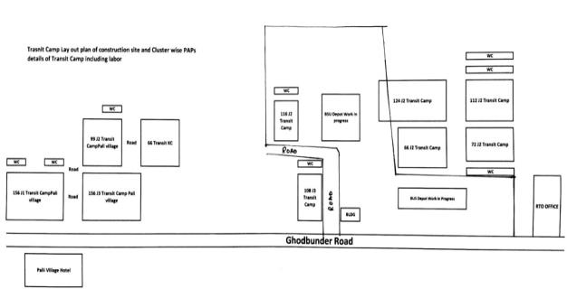**

# **F. Socio Economic Profile of affected Slum Dwellers:-**

The census & baseline survey including biometric survey was conducted in 2014 under the BSUP scheme. For addendum of ESMP report, MBMC has updated the survey list of 138 slum dwellers affected due to interference in the alignment for the construction of Ghurbandar depot in the month May, 2017. Summary of affected households (HHs), Projected Affected Families (PAFs) & Project Affected Persons (PAPs) are narrated as under:-

|  |  |  |  |  |
| --- | --- | --- | --- | --- |
| **Sl. No** | **Transit Camp Block No.** | **Total affected slum Dwellers (HHs)** | **Total PAFs** | **Total PAPs** |
| 1 | J-2 | 38 | 38 | 377 |
| 2 | J-3 | 100 | 100 | 151 |
|  | **Total** | **138** | **138** | **528** |

# **Population Composition**

The composition of the population in project area was found to be slightly skewed in favour of male with 58% compared to 42% of female. This is reflected in the sex ratio, with 840 females out of 1000 males.

Composition of sample population by age groups shows a predominance of working age group (18-59 years) at 56% over the young age group (0-17 years) is 42% and old age group (above 60 years) accounting for 02%..

|  |  |  |
| --- | --- | --- |
| **Total Population** | **No** | **% to Total Population** |
| Total Male | 307 | 58% |
| Total Female | 221 | 42% |
| **Total** | **528** | **100%** |
| **Sex Ratio (no. of F per 1000 M)** | **840** |  |
| **Age group** |  |  |
| 0-6 | 56 | 11% |
| 7-17 | 163 | 31% |
| 18-59 | 298 | 56% |
| 60+ | 11 | 2% |
| **Total** | **528** | **100%** |

# **Demographic Profile of affected slum dwellers:**

Total 138 slum dwellers household (HHs) are being affected by the project & total project affected population (PAPs) is 528. Out of 528 PAPs 45% are of general, 25% OBC, 29% SC & 01 % is of ST population.

|  |  |  |  |
| --- | --- | --- | --- |
| **Particulars** | **Total HHs** | **PAPs** | **% to Total Population** |
| General | 64 | 236 | 45% |
| OBC | 30 | 132 | 25% |
| SC | 42 | 154 | 29% |
| ST | 2 | 6 | 1% |
| **Total** | **138** | **528** | **100%** |

# **Income & Occupational Pattern:**

The occupation pattern shows (***Table)*** that primary sector workers engaged in tertiary sector (service, trade and business and self-employed professionals) i.e., 31% of the total workers. In tertiary sector, trade and business are major activities 20% female are housewives, 31% are students & 7% unemployed.

|  |  |  |
| --- | --- | --- |
| **Particulars** | **No** | **% to Total Population** |
| Infant (0-6) | 56 | 11% |
| Student | 166 | 31% |
| Unemployed | 36 | 7% |
| House Wife | 103 | 20% |
| Labour | 58 | 11% |
| Skilled Labour | 52 | 10% |
| Service | 39 | 7% |
| Business | 18 | 3% |
| **Total** | **528** | **100%** |

# **G. Consultations & Participations:**

Under BSUP scheme various public consultations and awareness campaigns were organized for appraising the short-term inconveniences and long term benefits of the project in order to gain full support of the beneficiaries.

For the shifting of 38 slum dwellers, are being affected due to interference in the alignment of construction of Ghorbander depot, MBMC was organized individual level public consultation at door step on dated 14th & 15th December, 2016, for the sensitization & awareness on entitlements under the scheme and also for the facilities covered in new transit camp. Individual level public consultation was executed by the MBMC –PIU staff Shri. Deepak Shrangare  - Social Development Specialist & Shri. Sadashiv Thanke    - Capacity Building & Training Coordinator

Before shifting of 38 slum dwellers, MBMC was served /displayed the notices to all slum dwellers residing in transit camp J-2 block on dated 23/01/2017 (Copy of notice is enclosed as annexure-4)

MBMC was organized Public Consultation meeting on dated 20/05/2017 for grievance redressal & feedback of satisfaction report, after shifting of 38 slum dwellers dated 23rd March, 2017, in the same BSUP block J-2 (15 to 20 meter behind the residing position). (Copy of Minutes of meeting, attendance sheet of participants & photograph is enclosed as annexure -4)

The Public Consultation was organized by the following member’s team.

**BSUP Project (Officer)**

1) Shri. Deepak Khambit   - Executive Engineer

2) Shri. Yatin Jadhav          - Deputy Engineer

**PIU Member**.

1) Shri. Deepak Shrangare  - Social Development Specialist

2) Shri. Sadashiv Thanke    - Capacity Building & Training Co-ordinator.

**Objective of public consultations & focus group discussion are –**

* establish rapport between the slum dwellers and other stakeholders for the success of the project;
* build an environment where people understand and appreciate the need and importance of the project;
* learn from the people about the issues in terms of the regional linkages, safety, and other social dimensions of the region/ area that need to be considered while execution of the project;
* facilitate the partnership and ownership of the community through their involvement in the decision-making process; and
* Understand and incorporate the views of the people in the execution process to minimize the future resistance and delays.
* Recording/registering the grievance for redressal.

# **H. Policy of legal Framework:**

At the central level, the Right to Fair Compensation and Transparency in Land Acquisition, Rehabilitation and Resettlement Act, 2013 and the National Resettlement and Rehabilitation Policy, 2007 are the applicable policies. Sub-projects conceived under ESCBSP currently do not involve any land acquisition or relocation of squatters and encroachers nor does

# **(I).The Right to Fair Compensation and Transparency in Land Acquisition, Rehabilitation and Resettlement Act, 2013**

| **Section** | **Aspect** | **Provision** |
| --- | --- | --- |
| **Preliminary Investigation for Determination if Social Impact and Public Purpose** | | |
| 4 | Preparation of Social Impact Assessment (SIA) | Undertaking a SIA to estimate the potential impacts in consultation with the concerned Panchayat/ Municipality/ Municipal Corporation |
| 5 | Public hearing for SIA | Public hearing to be held in the affected area after giving adequate publicity about date, time and venue for public hearing |
| 6 | Publication of SIA | SIA Report and Management Plan to be made available in the local language to the Panchayat/ Municipality/ Municipal Corporation |
| **Appraisal of Social Impact Assessment Report by an Expert Group** | | |
| 7 | Appraisal of the SIA by an expert group | SIA to be evaluated by an independent multi- disciplinary expert group as constituted under the project |
| 8 | Examination of proposals for land acquisition and SIA report by appropriate govt. | Recommend such area for acquisition that would ensure minimum displacement of people, minimum disturbance to infrastructure, ecology and minimum adverse impact on the individuals affected. |
| **Notification and Acquisition** | | |
| 11 | Publication of preliminary notification and power of officers thereupon | Publishing of notification in official gazette, in 2 daily newspapers including one in regional language, upload on appropriate govt. website. |
| 12 | Preliminary survey of land and power of officers to carry out survey | To determine the extent of land to be acquired |
| 14 | Lapse of SIA report | If a preliminary notification is not issued as per section 11 within 12 months of the appraisal of the SIA report by expert group, then a fresh SIA shall be required to be carried out. |
| 15 | Hearing of Objections | Any person affected by the notification under section 11 may within 60 days object to the preliminary notice of land acquisition. |
| 16 | Preparation of Rehabilitation and Resettlement Scheme (R & R S) | Conduct of census survey of the affected families. |
| 17 | Review of the R & RS | Review of the R & RS by the Collector |
| 18 | Approved R & RS to be made public | Approved R & RS to be made available in the local language to the Panchayat/ Municipality/ Municipal Corporation |
| 19 | Publication of declaration and summary of R & RS | Final declaration of R & RS along with a declaration of a resettlement area |
| 21 | Notice to persons interested | Publishing of public notice for acquisition of land |
| 23 | Enquiry and land acquisition award | Collector shall enquire into objections and make award of compensation due |
| 25 | Period within which an award shall be made | Collector shall make an award with a period of 12 months from the date of publication of declaration under section 19. |
| 26 | Determination of Market value of land | Determination of Market value of land by Collector based on the provisions of the subsections |
| 27-30 | Determination of compensation and award of solatium |  |
| **Rehabilitation and Resettlement Award** | | |
| 31 | Award of R & R for affected families | R & R award for affected families by Collector as per the entitlements provided |
| **Establishment of Land Acquisition, Rehabilitation and Resettlement Authority** | | |
| 64 | Reference to R& R Authority | In case of disagreement on the price awarded, within 6 weeks of the award the parties can put an objection to the Collector; if the collector doesn’t respond within 30 days then person can represent the case to the R& R Authority. |
| 74 | Appeal to High Court | Any person aggrieved by the award passed by the R& R Authority under section 69 may file an appeal in High Court. |

# **(II). The World Bank’s Safeguard Policies**

The World Bank’s Operational Policies (OP) includes guidance on Environmental Assessment requirements. The Bank’s Safeguard Policies, ten of them, is meant to ensure that operations of the Bank do not lead to adverse impacts or cause any harm. The Safeguard Policies are lumped into Environment, Rural Development, Social Development and International Law. The following four out of the ten are relevant for considerations under the ESMF.

* Environmental Assessment (OP 4.01);
* Involuntary Resettlement (OP/BP 4.12);
* Physical Cultural Resources (OP/BP 4.11)
* Natural Habitats (OP / BP 4.04)

# **(III).Slum Areas of Maharashtra (Improvement, Clearance & Redevelopment) Act, 2003**

1. The Principal Act, i.e., the Maharashtra Slum Areas (Improvement, Clearance and Redevelopment) Act was enacted in 1971. Amendments have been brought to the act in 2001 and 2003. The Act was brought into existence with basic aim of protecting the interests of the slum dwellers in the state. The key features are:
2. **The object of the principal Act is to make better provisions** for the improvement and clearance of slum areas in the state, to stop further proliferation of illegal and unauthorized structures, and to protect the occupiers from eviction. It was oriented more towards tolerance and improvement. The First Amendment was therefore brought out with an object of ‘effectively providing for protection of slum dwellers, their relocation and rehabilitation.’
3. All people in uninterrupted occupation of slum dwellings on or prior to January 1, 1995, who hold a photo pass (Identity card for slum dwellers) or documents equivalent to it, are considered to be ‘protected’ occupiers. They cannot be evicted from their dwellings unless their eviction is deemed necessary in the larger public interest, and this eviction is subject to their relocation and rehabilitation in accordance with schemes of the State Government.
4. Non-compliance with the schemes and terms of relocation and rehabilitation is equivalent to forfeiting of a claim for rehabilitation.
5. Any unauthorized or illegal structure constructed after January 1, 1995 is liable to be demolished with a show cause notice of 24 hours. (The First Amendment allows a period of up to 10 days to respond to the notice.)
6. The demolition of the unauthorized structures is the responsibility of the owner / occupier, and expenses for the same are to be recovered from the sale of the debris, and the owner / occupier, if a competent authority performs the act of demolition.
7. The construction of unauthorized structures, aiding / abetting such construction, and occupation of such structures with knowledge of their ‘unauthorized’ status, are deemed to be cognizable, non-bailable offences, liable to imprisonment and fine.
8. The authorities / officers who aid / abet such construction, or who fail to demolish such structures as per outlined procedure, are also liable to similar punishments on conviction. (It is significant to note that the earlier Ordinance considered offences committed by both non-officials and officials as non-bailable and cognizable. The current amendment however excludes offences committed by non-officials from the cognizable and non-bailable category.

The Act in sections 14 to 21 lists provisions for acquisition of land under slums for public purpose. The land would be acquired by a competent authority and compensation to be awarded to the affected people as determined by the competent authority. Any delay in payment of compensation would lead to its payment with interest.

# **(IV). Entitlement Framework for ESCBSP**

| **Category** | | **Type of Loss** | **Unit of Entitlement** | **Entitlement** | **Details** |
| --- | --- | --- | --- | --- | --- |
| A | Non-Titleholders | Encroachers | Household |  | * Will receive no compensation for land but assistance for shifting assets to the vulnerable groups (SC, ST, Women Headed Households and poor). Such assistance shall be given only to residential and commercial properties; * Encroachers will be notified a time in which to remove their assets; * Right to salvage materials from the demolished structure. |
| Squatters | Household | Assistance | * Right to salvage materials from the demolished structure * Shifting assistance of Rs. 10,000 for each displaced family. * Additional lump sum assistance of Rs. 10,000 per household to vulnerable groups such as – female headed households, households with disabled family members, households below poverty line, scheduled tribe and scheduled caste households etc. |
| B | Informal Business | Mobile and ambulatory vendors and Kiosks | Household | Assistance | To be provided assistance as per the Street Vendor’s Act, 2014:   * *Provided with a certificate to vend* * *Relocation/eviction shall be carried out by giving 30days notice* * *Relocated to a defined vending zone.* |
| C | Community infrastructure, cohesion and amenities | Common property resources | Community | Conservation, protection, compensatory replacement | * The common property resources and the community infrastructure shall be relocated in consultation with the community |
| D | Disruption | Temporary construction related impacts | Household | Assistance may be considered in special cases. | * Access to be maintained and when disruption occurs, losses can be substantiated, “assistance” will be considered for business losses. |

# **I. Income Restoration:**

Due to this temporary shifting of slum dwellers will be relocated to a transit camp within 200 meter from the present Transit camp. Slum dwellers were provided advance information/notices regarding the upcoming construction activities to ensure no or minimum disruption in their livelihood. If, and when required they will be assisted in temporary shifting for the continued economic and livelihood activities.

For continuity of depot construction, 38 slum dwellers of Block J-2, who are affected/ interference in the alignment of the progress of Ghodbundar Depot construction, has already been shifted to same BSUP J-2 block Ghodbundar transit camp (15 to 20 meter behind the residing position) on dated 23rd March, 2017. MBMC has provided basic amenities. i.e. Electric supply, water supply, proper sanitation, common toilets etc. MBMC has also provided the transportation assistance in terms of 40 labor (approx. one labour to each slum dwellers) to facilitate and shift their luggage.

Rest 100 slum dwellers of BSUP block J-3 will be shifted 200 meter distance from the Ghodbundar Site Pali Village Transit camp for intermediate relocation having basic amenities. i.e. Electric supply, water supply, proper sanitation, common toilets etc. up to August,2017. Livelihood of affected 138 slum dwellers will not be affected due to intermediate shifting from another transit camp.

# **J. Grievance Redressal Mechanism:**

Grievance redressal mechanism is an important aspect in projects involving land development. The redressal of grievance is important to avoid unnecessary legal delays and cost overrun of the project. Also, this is a forum for people to express their dissatisfaction over environmental pollution from construction or operation activities, compensation and R&R provisions.

The proposed projects MBMC do not envisage any land acquisition impacts. Impact on environment and social aspects are also limited in nature and quantum. A Grievance Redressal Committee (GRC) has been constituted within the PIU to monitor and review the progress of implementation of the EMP / ESMP and rehabilitation and resettlement plan for the affected families. The GRC has been formed/ constituted vide letter date 20.04.2013; GRC members are:

|  |  |  |
| --- | --- | --- |
| **S.No.** | **Post** | **Name** |
| 1. | Deputy Commissioner (Social Development) |  |
| 2. | City Engineer |  |
| 3. | Executive Engineer (PWD) |  |
| 4. | Executive Engineer (water supply) |  |
| 5. | Social Development Officer |  |
| 6. | Assistant Commissioner Tax |  |
| 7. | Senior Manager (Reliance Infra.) |  |
| 8. | Rationing Officer |  |

The functions of the Grievance Redressal Committee shall be:

1. The Commissioner holds public meeting on Mondays and Thursdays for grievance redressal
2. Complaints register is maintained; it is sent to respective departments or to Commissioner; First level of resolution is at department level, Commissioner intervenes if required
3. Online registration of grievances through the Municipal Corporation’s website.
4. The GRC shall also carry out post implementation environmental and social audits wherever EMP / ESMP / resettlement activities are to be undertaken.

MBMC has organized Public Consultation meeting on dated 20/05/2017 for grievance redressal & feedback for the affected slum dwellers of J-2, which has already been shifted on dated 23rd March,2017 in the same BSUP block J-2 approx. 15 to 20 meter behind their residing position.

# **K. Relocation Plan of affected 246 slum dwellers :**

# **Ghodbundar Transit camp J-2 Block 38 Slum Dwellers:**

Ghodbundar Depot site BSUP Transit camp J-2 total 38 slum dwellers were affected due to alignment of construction work, have been shifted intermediately from outside the alignment at the same adjacent place on dated 23rd March,2017 with basic amenities i.e. Electric supply, water supply, proper sanitation, common toilets. etc. for continuity of the depot construction work.

The activities were performed by MBMC, for proper relocation of 38 slum dwellers in a manner that they are not adversely impacted during relocation to another nearby temporary site transit camp. Supports provided by MBMC are as under:

* Before shifting of slum dwellers, MBMC has conducted individual level public consultation at door step on dated 14th & 15th December, 2016, for the sensitization & awareness on entitlements under the scheme and facilities covered in new transit camp etc. (Photograph is attached in annexure 2)
* Individual level public consultation was executed by the MBMC –PIU staff Shri. Deepak Shrangare  - Social Development Specialist & Shri. Sadashiv Thanke    - Capacity Building & Training Coordinator.
* MBMC has verified all affected slum dwellers residing in transit camp, are covered under BSUP scheme eligibility criteria for allotment of houses.
* MBMC has served /displayed the notices to all slum dwellers residing in transit camp J-2 block on dated 23/01/2017, before shifting of 38 slum dwellers, (Copy of notice is enclosed as annexure-3).
* MBMC has deputed Executive Engineer Sri, Deepak Khambit & Dy Engineer Sri, Yati Jadhav for proper compliance during shifting & relocation of slum dwellers on dated 23rd March, 2017.
* MBMC has provided support of transportation assistance in terms of 40 labor (approx. one labour to each slum dwellers) to shift their luggage in the same BSUP block J-2 which is15 to 20 meter behind the residing position.
* After shifting of 38 slum dwellers MBMC has organized Public Consultation meeting on dated 20/05/2017 for grievance redressal & feedback of satisfaction report. (Copy of minutes of meeting with attendance sheet & photograph is attached in Annexure 5, 6 & 7)
* MBMC will issue Identity Cards/Entitlement Card to all affected 38 slum dwellers.

# **Ghodbunder Transit camp J-3 Block 100 Slum Dwellers:**

Ghodbundar Depot site BSUP Transit camp J-3 total 100 slum dwellers will be affected due to alignment of construction work. These slum dwellers will be shifted 200 meter distance at 156 Pali Village Transit Camp on dated August,2017 .

MBMC will ensure on following activities for providing support & proper relocation of 100 slum dwellers:

* Public consultation & awareness to all affected slum dwellers for the sensitization & awareness on entitlements under the scheme and facilities covered in new transit camp etc
* MBMC will serve and display the notices to all affected 100 slum dwellers residing in transit camp J-3 block.
* MBMC will provide transportation assistance in terms of transportation vehicle for all 100 slum dwellers to shift them to New Transit camp i.e 200 meter distance at 156 Pali Village Transit Camp
* MBMC will ensure community utilities & amenities like electric connection with individual meter, common water supply, community toilet, Road, drains etc in the intermediate transit camp at Palli Village.
* After shifting of 100 slum dwellers, MBMC will organize Public Consultation meeting for grievance redressal & feedback.
* MBMC will issue Identity Cards/Entitlement Card to all affected 100 slum dwellers.

# **L. Institutional & Implementation Arrangement Plan:**

The MBMC project under GEF-ESCBS does not envisage triggering of significant environmental / social impacts, i.e. projects with potential to trigger impacts on environmentally sensitive areas, or large scale resettlement activities are not anticipated. In overall project scope of ESCBS depot construction is involved in the city of Mira- Bhayandar,. Though construction of Ghorbandar depot is through counterpart funding, the ESMF addresses impacts likely from this activity. MBMC project shall be subjected to necessary environmental and social assessments, as mandated by the GoI / state governments and conforming to the safeguard policies of the World Bank Environmental and Social Safeguard requirements



# **M. Action Plan & Time Line for Relocation of affected Slum Dwellers:**-

Action Plan & time line for intermediate relocation of & final relocation by providing housing units with utilities & amenities are as under:-

|  |  |  |  |  |  |  |
| --- | --- | --- | --- | --- | --- | --- |
| **Sl.No.** | **Particulars** | **Activity** | **Location** | **Tentative Date** | **Allocation of responsibility** | **Remarks** |
| 1 | Shifting of 38 slum dwellers of BSUP Scheme J-2 Block with utilities & amenities. | Intermediate shifting | Adjacent to Vacant Transit camp J-2 Block | Already shifted on 23rd March,2017 | MBMC | Livelihood impact-NIL |
| 2 | Shifting of 100 slum dwellers of BSUP Scheme J-3 Block with utilities & amenities. | Intermediate shifting | 156 Pali village Ghodbundar transit camp.200 meter distance | Proposed on August,2017 | MBMC | Livelihood impact-NIL |

# **N.** **Mechanism for Monitoring of R&R activities:**

MBMC Project Implementation Unit (PIU) will be responsible for compliance monitoring and reporting to the PMU at the centre. An officer in PIU i.e Deputy Commissioner (Social Development) has been designated as the Environment & Social Safeguards officer to ensure compliance of the project activities with the World Bank safeguards as well as oversee implementation of environment and social provisions as per the ESMF, EMP and RAP where applicable.

The objectives of Monitoring and Evaluation include:

* Project management and timely completion;
* Successful completion of Environmental management, R&R activities identified in the EMP and R&R plan as per the implementation schedule;
* Compliance with the Environmental policy, R&R policy and entitlement framework.

The safeguards officer shall play a key role in reporting the progress of implementation as well as compliance to the PIU, PMU and the World Bank.

| **S. No.** | **Particulars of activity** | **Frequency of Reporting** | **Responsible Agency** | **Monitoring Agency** |
| --- | --- | --- | --- | --- |
| 1 | Progress on Census and Socio-Economic Survey | One time, immediately post screening | Environment and Social Officer, PIU | PIU |
| 2 | Verification of Squatters and Encroachers | One time | Environment and Social Officer, PIU | PIU |
| 3 | Distribution of Entitlements and Assistances | Before initiating civil works | Environment and Social Officer, PIU | PIU |
| 4 | Community Consultations | As soon as conducted at Pre-construction, construction and Post-construction Stage | Environment and Social Officer, PIU | PIU |
| 5 | Progress of Grievance Redressal | Monthly | Environment and Social Officer, PIU | PIU |

# **O. Status of Relocation Site for BSUP slum Dwellers:**

Out of 4136 dwelling units, construction work is under progress for 2160 houses and shall be completed up to March, 2019.

|  |  |  |  |  |  |  |  |
| --- | --- | --- | --- | --- | --- | --- | --- |
| **Janta Nagar** | | | | | | | |
| **Sr. No** | **Building No** | **No’s of floor** | | **DU’s** | | **Stage of Work** | **Tentative date of completion** | |
| 1 | 1 | G+8 | | 179 | | Completion Stage | Apr 17 | |
| 2 | 2 | G+16 | | 299 | | Foundation Stage | Dec 18 | |
| 3 | 3 | G+16 | | 299 | | RCC up to 4th floor | Dec 18 | |
| 4 | 4 | G+16 | | 299 | | Plinth Level | Dec 18 | |
| 5 | 5 | G+16 | | 299 | | Plinth Level | Dec 18 | |
| 6 | 6 | G+16 | | 294 | | RCC up to 2nd floor | Dec 18 | |
| 7 | 7 | G+16 | | 362 | | Foundation Stage | Dec 18 | |
| **Kashi Church** | | | | | | | |
| 9 | 3 | G+8 | | 129 | | RCC Completion Stage | Dec 17 | |
| **Total** | | | **2160** | |  | | |

|  |  |
| --- | --- |
| **G:\New_folder_(2)\Site Photos 05012017\JN Bldg No 1\20170105_130852.jpg** | **G:\New_folder_(2)\Site Photos 05012017\JN Bldg No 1\20170105_130924.jpg** |
| **Status of construction of BSUP housing units** | |

# **Annexure -1 Photographs of Relocated 38 Slum Dwellers in BSUP Transit Camp J-2 block shifted on dated 23rd March,2017**

|  |  |
| --- | --- |
| **Status of J-2 Transit Camp Relocated 38 Slum Dwellers** | |
| C:\Users\Sharad Misra\Downloads\IMG20170617170121.jpg | C:\Users\Sharad Misra\Downloads\IMG20170617165934.jpg |
| C:\Users\Sharad Misra\Downloads\IMG20170617170349.jpg | C:\Users\Sharad Misra\Downloads\IMG20170617170012.jpg |

# **Annexure -2: Office Order for Grievance Redressal Committee dated 20.04.2013**

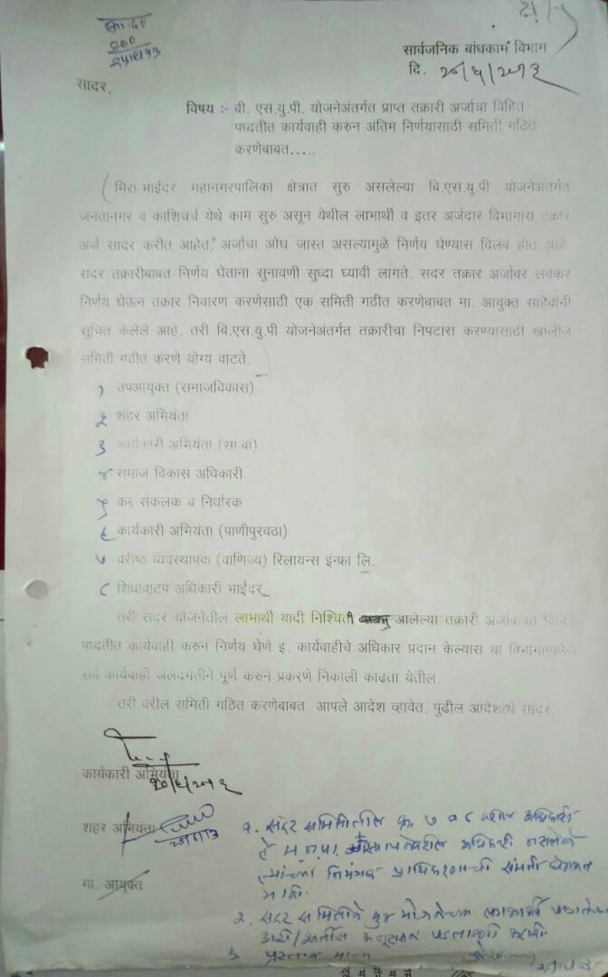

# **Annexure -3 Individual Public Consultation at door step for shifting of 38 Slum Dwellers on dated 14th & 15th December, 2016**

**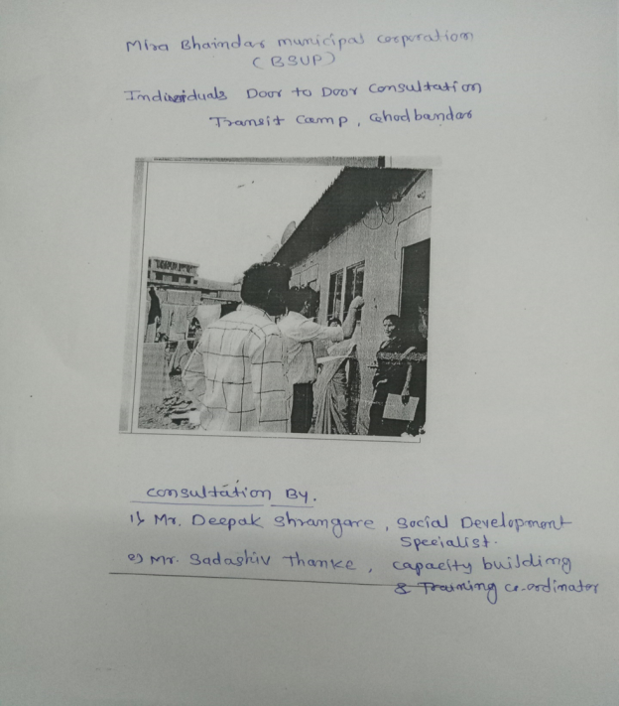**

# **Annexure -4 Copy of Notice Served before shifting of slum dwellers dated 23.01.2017**

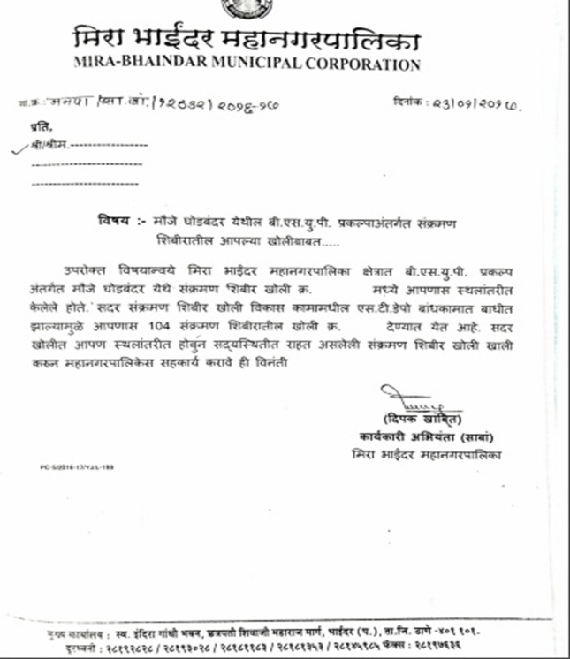

# **Annexure -5 Copy of Minutes of meeting for Public Consultation dated 20.05.2017**

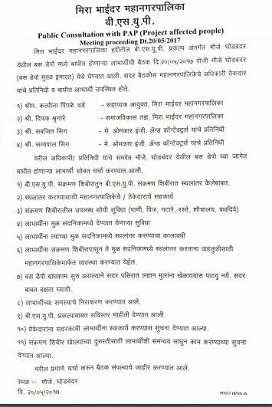

# **Annexure -6 Copy of attendance sheet of Public Consultation meeting dated 20.05.2017   attended 46 participants**

# 



# **Annexure 7: Photographs of Public Consultation Meeting dated 20.05.2017**

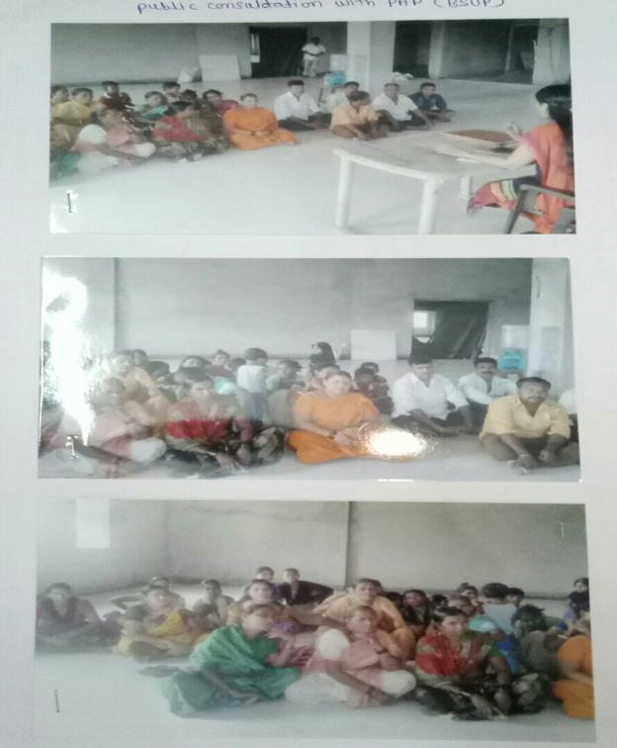

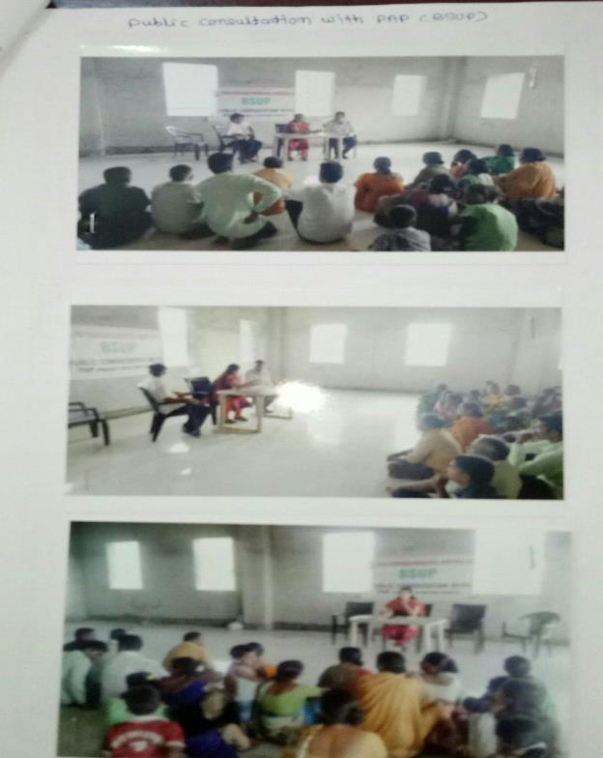

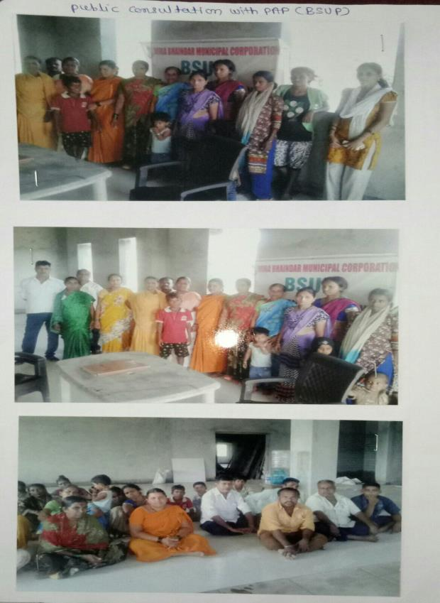

# **Annexure -8: Socio-economic Profile of affected 138 Slum Dwellers**

|  |
| --- |
| **Mira Bhayandar Municipal Corporation** |
| **List of Project affected Slum Dwellers residing in Transit camp of BSUP Scheme** |

| **Sr.no.** | **Hutment No.** | **Transit Camp No.** | **Name of Affected Household & Dependent Family members** | **Sex (Male/ Female)** | **Relationship with Affected HH (Wife-W, Son-S Daughter -D, Father-Fa. Mother-Mo.)** | **Age** | **Number of affected /dependent persons** | **Social Status (SC/ST/OBC/General)** | **Occupation of Householder** | **Monthly Income of Family** | **Status (Shifted/ Proposed)** | **Remarks** |
| --- | --- | --- | --- | --- | --- | --- | --- | --- | --- | --- | --- | --- |
| **1** | **2** | **3** | **4** | **5** | **6** | **7** | **8** | **9** | **10** | **11** | **12** | **13** |
| **1** | **1540** | **1** | **Ramabai Karbhari Gavli** | **F** | **Self** | **22** | **4** | **SC** | **Labour** | **3000** | **Proposed** |  |
|  |  |  | Karbhari rambhau Gavli | M | Husband | 25 |  | SC | Labour | 3000 |  |  |
|  |  |  | Aakansha | F | Daughter | 4 |  | SC | Education | - |  |  |
|  |  |  | Shailesh | M | Son | 2 |  | SC | Education | - |  |  |
| **2** | **2266** | **2** | **Nanhelal Vijay Bahadur Singh** | **M** | **Self** | **40** | **5** | **General** | **Company** | **4000** | **Proposed** |  |
|  |  |  | **Indudevi** | **F** | **Wife** | **35** |  | **Singh** | **House wife** | **-** | **Proposed** |  |
|  |  |  | Dharmendra | M | Son | 12 |  | Singh | Education | - |  |  |
|  |  |  | Dimple | F | Daughter | 10 |  | Singh | Education | - |  |  |
|  |  |  | Babita |  | Daughter | 6 |  |  |  |  |  |  |
| **3** | **2224/A** | **3** | **Rupa Arvind Sigh** | **M** | **Self** | **1** | **1** | **General** |  |  | **Proposed** |  |
| **4** | **2749/A** | **4** | **Nisha Vinodkumar Pashi** | **M** | **Self** | **1** | **1** | **SC** |  |  | **Proposed** |  |
| **5** | **2528-A** | **5** | **Sachin Suresh Bujad** | **M** | **Self** | **22** | **3** | **ST** | **Student** | **-** | **Proposed** |  |
|  |  |  | Suresh Bujad | M | Father | 45 |  | ST | Labour | - |  |  |
|  |  |  | Ranjana | F | Mother | 38 |  | ST | House wife | - |  |  |
| **6** | **2525/B** | **6** | **Suresh Ganpat Bujad** | **M** | **Self** | **40** | **1** | **SC** |  |  | **Proposed** |  |
| **7** | **2414** | **7,13,14** | **Ashok Maruti Ransurey** | **M** | **Self** | **35** | **5** | **SC** | **Job** | **3000** | **Proposed** |  |
|  |  |  | Sanu Ashok Ransurey | F | Wife | 30 |  | Vadari | House wife | - |  |  |
|  |  |  | Rakesh | M | Son | 15 |  | Vadari | Education | - |  |  |
|  |  |  | Manish | M | Son | 8 |  | Vadari | Education | - |  |  |
|  |  |  | Reshma | F | Daughter | 9 |  | Vadari | Education | - |  |  |
| **8** | **2410** | **8** | **Sunil Maruti Jadhav** | **M** | **Self** | **30** | **4** | **OBC** | **Job** | **3000** | **Proposed** |  |
|  |  |  | Sanjana Sunil Jadhav | F | Wife | 27 |  | H. Maratha | House wife | - |  |  |
|  |  |  | Samiksha | F | Daughter | 6 |  | H. Maratha | Education | - |  |  |
|  |  |  | Roshni | F | Daughter | 4 |  | H. Maratha | Education | - |  |  |
| **9** | **1200** | **9** | **Nitin Rajaram Pawar** | **M** | **Self** | **22** | **3** | **SC** | **Driver** | **6000** | **Proposed** |  |
|  |  |  | Rajaram | M | Father | 40 |  | SC | Labour | 4000 |  |  |
|  |  |  | Lilawati | F | Mother | 35 |  | SC | Labour | 4000 |  |  |
| **10** | **2278** | **10** | **Ramnaresh Dashrath Goud** | **M** | **Self** | **55** | **4** | **General** | **Labour** | **3000** | **Proposed** |  |
|  |  |  | Geetadevi Dashrath Goud | F | Wife | 32 |  | Goud | Labour | 3000 |  |  |
|  |  |  | Lalu | M | Son | 12 |  | Goud | Education | - |  |  |
|  |  |  | Raju | M | Son | 10 |  | Goud | Education | - |  |  |
| **11** | **2297** | **11** | **Habibu Rehman Abdul Khan** | **M** | **Self** | **21** | **4** | **General** | **Job** | **5000** | **Proposed** |  |
|  |  |  | Ajiju | M | Brother | 23 |  | Muslim | Education | - |  |  |
|  |  |  | Jahirunissa | F | Sister In Law | 28 |  | Muslim | House wife | - |  |  |
|  |  |  | Imraan | F | Niece | 10 |  | Muslim | Education | - |  |  |
| **12** | **2299** | **12** | **Hasina Munir Khan** | **F** | **Self** | **19** | **4** | **General** | **House wife** | **2000** | **Proposed** |  |
|  |  |  | Hafijmanis | F | Mother | 42 |  | Muslim | House wife | - |  |  |
|  |  |  | Aasif | M | Brother | 13 |  | Muslim | Education | - |  |  |
|  |  |  | Rubina | F | Sister | 16 |  | Muslim | Education | - |  |  |
| **13** | **2110** | **15,16** | **Munalal Lalbihari Mali** | **M** | **Self** | **43** | **4** | **OBC** | **Garment Helper** | **3000** | **Proposed** |  |
|  |  |  | Manbhavti Devi Mali | F | Wife | 41 |  | Mali | House wife | - |  |  |
|  |  |  | Pradeep | M | Son | 20 |  | Mali | Education | - |  |  |
|  |  |  | Manoj | M | Son | 10 |  | Mali | Education | - |  |  |
| **14** | **2109** | **17,18** | **Manbas Rajdev Yadav** | **M** | **Self** | **38** | **6** | **OBC** | **Driver** | **3500** | **Proposed** |  |
|  |  |  | Aasha Manbas Yadav | F | Wife | 34 |  | Yadav | House wife | - |  |  |
|  |  |  | Kusum | F | Daughter | 15 |  | Yadav | Education | - |  |  |
|  |  |  | Avind | M | Son | 11 |  | Yadav | Education | - |  |  |
|  |  |  | Abhishek | M | Son | 10 |  | Yadav | Education | - |  |  |
|  |  |  | Babita | F | Daughter | 6 |  | Yadav | Education | - |  |  |
| **15** | **2286** | **19** | **Subhash Rajdev Singh** | **M** | **Self** | **31** | **4** | **OBC** | **Job** | **3000** | **Proposed** |  |
|  |  |  | Shantidevi Subhash Singh | F | Wife | 28 |  | Yadav | House wife | - |  |  |
|  |  |  | Pooja | F | Daughter | 8 |  | Yadav | Education | - |  |  |
|  |  |  | Aarti | F | Daughter | 6 |  | Yadav | Education | - |  |  |
| **16** | **1900** | **20** | **Ismail Sikandar Shaikh** | **M** | **Self** | **46** | **4** | **General** | **Job** | **5000** | **Proposed** |  |
|  |  |  | Sabina Ismail Shaikh | F | Wife | 32 |  | Muslim | House wife | - |  |  |
|  |  |  | Sikandar | M | Son | 11 |  | Muslim | Education | - |  |  |
|  |  |  | Shainaaz | F | Daughter | 8 |  | Muslim | Education | - |  |  |
| **17** | **1599** | **21** | **Shamnarayan Chouhaan** | **M** | **Self** | **42** | **4** | **General** | **Labour** | **3000** | **Proposed** |  |
|  |  |  | Radhadevi Chouhaan |  |  | 38 |  |  |  |  |  |  |
|  |  |  | Rinku |  |  | 12 |  |  |  |  |  |  |
|  |  |  | Jogesh |  |  | 9 |  |  |  |  |  |  |
| **18** | **2617** | **22** | **Vikram Bapurav Raut** | **M** | **Self** |  | **1** | **General** |  |  | **Proposed** |  |
| **19** | **2528** | **23,24** | **Panchidev Shanku Jaiswal** | **M** | **Self** | **40** | **6** | **OBC** | **Job** | **2000** | **Proposed** |  |
|  |  |  | Rameta Panchidev Jaiswal | F | Wife | 30 |  | Jaiswal | House wife | - |  |  |
|  |  |  | Kusum | F | Daughter | 15 |  | Jaiswal | Education | - |  |  |
|  |  |  | Dipak | M | Son | 13 |  | Jaiswal | Education | - |  |  |
|  |  |  | Reena | F | Daughter | 10 |  | Jaiswal | Education | - |  |  |
|  |  |  | Vishal | M | Son | 8 |  | Jaiswal | Education | - |  |  |
| **20** | **2099** | **25** | **Tejbahadur Amarpal Singh** | **M** | **Self** | **52** | **4** | **General** | **Wachman** | **5000** | **Proposed** |  |
|  |  |  | Sitadevi Tejbahadur Singh | F | Wife | 35 |  | Takur | House wife | - |  |  |
|  |  |  | Dipak | M | Son | 15 |  | Takur | Education | - |  |  |
|  |  |  | Rahul | M | Son | 19 |  | Takur | Education | - |  |  |
| **21** | **2701** | **26** | **Dharmendra Bakelal Yadar** | **M** | **Self** |  | **1** | **OBC** |  |  | **Proposed** |  |
| **22** | **2722/O** | **27** | **Rajeshwar Krishna Singh** | **M** | **Self** |  | **1** | **General** |  |  | **Proposed** |  |
| **23** | **2111** | **28** | **Sursh Dabhade** | **M** | **Self** | **30** | **4** | **SC** | **Labour** | **3000** | **Proposed** |  |
|  |  |  | Mala Suresh Dabhade | F | Wife | 25 |  | SC | Labour | 3000 |  |  |
|  |  |  | Manoj | M | Son | 10 |  | SC | Education | - |  |  |
|  |  |  | Pooja | F | Daughter | 7 |  | SC | Education | - |  |  |
| **24** | **2112** | **29,30** | **Ali Gyasuddin Shaikh** | **M** | **Self** | **26** | **4** | **Muslim** | **Labour** | **6000** | **Proposed** |  |
|  |  |  | Samiraa Ali Shaikh | F | Wife | 24 |  | Muslim | House wife | - |  |  |
|  |  |  | Sabiraa | F | Daughter | 5 |  | Muslim | Education | - |  |  |
|  |  |  | Sameer | M | Son | 2 |  | Muslim | Education | - |  |  |
| **25** | **1372** | **31,32** | **Bindu Paal** | **M** | **Self** | **42** | **4** | **SC** | **Glass Lining** | **2000** | **Proposed** |  |
|  |  |  | Shashila Devi | F | Wife | 39 |  | Paal | House wife | - |  |  |
|  |  |  | Ramsharan | M | Son | 18 |  | Paal | Education | - |  |  |
|  |  |  | Seemadevi | F | Daughter | 15 |  | Paal | Education | - |  |  |
| **26** | **139** | **33** | **Salma Mokidh Shaikh** | **F** | **Self** | **32** | **4** | **Muslim** | **House wife** | **-** | **Proposed** |  |
|  |  |  | Mokidh Shaikh | M | Husband | 35 |  | Muslim | Labour | 3000 |  |  |
|  |  |  | Shohana | F | Daughter | 14 |  | Muslim | Education | - |  |  |
|  |  |  | Sofiyaan | M | Son | 10 |  | Muslim | Education | - |  |  |
| **27** | **1165/C** | **34** | **Champa Umesh Rajbhar** | **F** | **Self** | **45** | **4** | **SC** | **House wife** | **-** | **Proposed** |  |
|  |  |  | Umesh Vishwanath Rajbhar | M | Husband | 50 |  | Rajbhar | Labour | 3000 |  |  |
|  |  |  | Kruti | F | Daughter | 16 |  | Rajbhar | Education | - |  |  |
|  |  |  | Neha | F | Daughter | 11 |  | Rajbhar | Education | - |  |  |
| **28** | **2333/A** | **35** | **Mulayamsigh Phulchand Yadar** | **M** | **Self** |  | **2** | **OBC** | **Service** | **6000** | **Proposed** |  |
|  |  |  | Sulekha Mulayamsingh Yadav | F |  |  |  |  |  |  |  |  |
| **29** | **2349** | **37** | **Deepak Anant Gurav** | **M** | **Self** |  | **2** | **General** | **Service** | **4000** | **Proposed** |  |
|  |  |  | Vaishali Deepak Gurav |  |  |  |  |  |  |  |  |  |
| **30** | **1150** | **39** | **Mehbub Chand Shaikh** | **M** | **Self** | **35** | **4** | **Muslim** | **Driver** | **7000** | **Proposed** |  |
|  |  |  | Khairun Mahbub Shaikh | F | Wife | 30 |  | Muslim | House wife | - |  |  |
|  |  |  | Gaus | M | Son | 12 |  | Muslim | Education | - |  |  |
|  |  |  | Karishma | F | Daughter | 11 |  | Muslim | Education | - |  |  |
| **31** | **1168/A** | **40** | **Babu Ibrahim Munjevar** | **M** | **Self** | **30** | **4** | **Muslim** | **Driver** | **3000** | **Proposed** |  |
|  |  |  | Shamera Babu Munjevar | F | Wife | 22 |  | Muslim | House wife | - |  |  |
|  |  |  | Billi | F | Daughter | 6 |  | Muslim | Education | - |  |  |
|  |  |  | Afarid | M | Son | 4 |  | Muslim | - | - |  |  |
| **32** | **979** | **41** | **Laxman Dayaram Mishara** | **M** | **Self** |  | **1** | **General** |  |  | **Proposed** |  |
| **33** | **1167/B** | **42** | **Dropati Vithoba Lahane** | **F** | **Self** | **28** | **4** | **General** | **House wife** |  | **Proposed** |  |
|  |  |  | Vithoba Limbaji Lahane |  |  | 24 |  |  |  |  |  |  |
|  |  |  | Reena |  |  | 3 |  |  |  |  |  |  |
|  |  |  | Riteeka |  |  | 1 |  |  |  |  |  |  |
| **34** | **1017/A** | **43** | **Ratnakar Mudund Naik** | **M** | **Self** |  | **1** | **General** |  |  | **Proposed** |  |
| **35** | **P-65** | **44** | **Tahera Moh. Karim Shaikh** | **F** | **Self** | **52** | **4** | **Muslim** | **House wife** |  | **Proposed** |  |
|  |  |  | Muhammad Karim Shaikh |  |  | 48 |  |  |  |  |  |  |
|  |  |  | Shanwaj |  |  | 23 |  |  |  |  |  |  |
|  |  |  | Saidaa |  |  | 20 |  |  |  |  |  |  |
| **36** | **640** | **45,46** | **Indravati Shriram Jaiswal** | **F** | **Self** | **55** | **7** | **OBC** | **House wife** | **-** | **Proposed** |  |
|  |  |  | Shriram Jaiswal | M | Husband | 60 |  | Jaiswal | Labour | 4000 |  |  |
|  |  |  | Chandan | M | Son | 30 |  | Jaiswal | Labour | 3500 |  |  |
|  |  |  | Niranjan | M | Son | 25 |  | Jaiswal | Labour | 3000 |  |  |
|  |  |  | Rinku | F | Listen | 22 |  | Jaiswal | House wife | - |  |  |
|  |  |  | Neha | F | Listen | 19 |  | Jaiswal | House wife | - |  |  |
|  |  |  | Shweta | F | Daughter | 22 |  | Jaiswal | Education | - |  |  |
| **37** | **581** | **47** | **Parmeshwar Mahipati Tigote** | **M** | **Self** |  | **1** | **OBC** |  |  | **Proposed** |  |
| **38** | **1015** | **48** | **Vijay Shankar Dhavale** | **M** | **Self** | **34** | **4** | **SC** | **Job** | **4000** | **Proposed** |  |
|  |  |  | Shaileja Vijay Dhavle | F | Wife | 30 |  | SC | House wife | - |  |  |
|  |  |  | Tejaswini | F | Daughter | 14 |  | SC | Education | - |  |  |
|  |  |  | Sanskruti | F | Daughter | 8 |  | SC | Education | - |  |  |
| **39** | **1549** | **49** | **Harihar Ramsamukh Visvakarma** | **M** | **Self** | **76** | **4** | **OBC** | **Labour** | **4000** | **Proposed** |  |
|  |  |  | Kalavatidevi Harihar Vishvakarma | F | Wife | 71 |  | Vishwakarma | House wife | - |  |  |
|  |  |  | Kanayalal | M | Son | 31 |  | Vishwakarma | Labour | 3500 |  |  |
|  |  |  | Rakesh | M | Son | 21 |  | Vishwakarma | Education | - |  |  |
| **40** | **1552** | **50** | **Sanjiv Parmeshwari Pathak** | **M** | **Self** | **28** | **3** | **General** | **Company** | **4500** | **Proposed** |  |
|  |  |  | Nishu | F | Wife | 25 |  | Brhaman | House wife | - |  |  |
|  |  |  | Gungun | F | Daughter | 1 |  | Brhaman | - | - |  |  |
| **41** | **1539** | **51** | **Ramkishor Ramnaresh Chouhan** | **M** | **Self** | **36** | **3** | **General** | **Driver** | **2500** | **Proposed** |  |
|  |  |  | Kevladevi Ramkishor Chauhan | F | Wife | 32 |  | Chauhan | House wife | - |  |  |
|  |  |  | Dharmendra | M | Son | 13 |  | Chauhan | Education | - |  |  |
| **42** | **2286** | **52** | **Sunil** | **M** | **Self** | **11** | **1** | **OBC** |  |  | **Proposed** |  |
| **43** | **2285** | **53** | **Doman Vasudev Yadav** | **M** | **Self** | **48** | **4** | **OBC** | **Job** | **2500** | **Proposed** |  |
|  |  |  | Meenadevi Doman Yadav | F | Wife | 38 |  | Yadav | House wife | - |  |  |
|  |  |  | Manojkumar | M | Son | 19 |  | Yadav | Education | - |  |  |
|  |  |  | Sanojkumar | M | Son | 11 |  | Yadav | Education | - |  |  |
| **44** | **1355** | **54** | **Ashokkumar Sitaram Yadav** | **M** | **Self** | **38** | **4** | **OBC** | **Job** | **4000** | **Proposed** |  |
|  |  |  | Urmila Yadav | F | Wife | 35 |  | Yadav | House wife | - |  |  |
|  |  |  | Mahesh | M | Son | 15 |  | Yadav | Education | - |  |  |
|  |  |  | Pratibha | F | Daughter | 11 |  | Yadav | Education | - |  |  |
| **45** | **1012** | **55** | **Pratima Sudhakar Waghmare** | **F** | **Self** | **35** | **3** | **SC** | **Job** | **2000** | **Proposed** |  |
|  |  |  | Sudhakar | M | Husband | 45 |  | SC | Labour | 3000 |  |  |
|  |  |  | Dharmpaal | M | Son | 19 |  | SC | Education | - |  |  |
| **46** | **1013** | **56** | **Chhaya Madhav Kamble** | **F** | **Self** | **40** | **4** | **SC** | **House wife** | **-** | **Proposed** |  |
|  |  |  | Madhav | M | Husband | 55 |  | SC | Labour | 3500 |  |  |
|  |  |  | Ratnadeep | M | Son | 25 |  | SC | Education | - |  |  |
|  |  |  | Shubham | M | Son | 20 |  | SC | Education | - |  |  |
| **47** | **1014** | **57** | **Aasha Laxman Sarje** | **F** | **Self** | **28** | **4** | **SC** | **House wife** | **-** | **Proposed** |  |
|  |  |  | Laxman Sarje | M | Husband | 32 |  | SC | Labour | 3000 |  |  |
|  |  |  | Gulkesh | M | Son | 10 |  | SC | Education | - |  |  |
|  |  |  | Rushikesh | M | Son | 8 |  | SC | Education | - |  |  |
| **48** | **1149** | **58** | **Maisuda Server Shaikh** | **F** | **Self** | **30** | **2** | **Muslim** | **House wife** | **-** | **Proposed** |  |
|  |  |  | Sarver Kureshi Shaikh | M | Father | 70 |  | Muslim | - | - |  |  |
| **49** | **1423** | **59** | **Kulsum Babu Chudesera** | **F** | **Self** | **35** | **4** | **OBC** | **Labour** | **1500** | **Proposed** |  |
|  |  |  | Babubai Altarakha Chudesara | M | Husband | 45 |  | Teli | Labour | 3000 |  |  |
|  |  |  | Firoj | M | Son | 21 |  | Teli | Education | - |  |  |
|  |  |  | Aasif | M | Son | 15 |  | Teli | Education | - |  |  |
| **50** | **2701** | **60** | **Dharmendra Bakelal Yadar** | **M** | **Self** |  | **5** | **OBC** | **Driver** | **3500** | **Proposed** |  |
|  |  |  | Radhika Dharmendra Yadav |  |  |  |  |  |  |  |  |  |
|  |  |  | Aniket |  |  | 9 |  |  |  |  |  |  |
|  |  |  | Ankit |  |  | 5 |  |  |  |  |  |  |
|  |  |  | Nikita |  |  | 3 |  |  |  |  |  |  |
| **51** | **1255/A** | **61** | **Vitthal Sitaram Kote** | **M** | **Self** |  | **1** | **General** |  |  | **Proposed** |  |
| **52** | **641** | **63** | **Gulab Bajrang More** | **M** | **Self** | **33** | **4** | **General** | **Agency** | **2000** | **Proposed** |  |
|  |  |  | Maya More | F | Wife | 30 |  | Maratha | House wife | - |  |  |
|  |  |  | Namrata | F | Daughter | 10 |  | Maratha | Education | - |  |  |
|  |  |  | Amar | M | Son | 8 |  | Maratha | Education | - |  |  |
| **53** | **1007** | **65** | **Chanchala Ayodhya Singh** | **F** | **Self** | **30** | **4** | **OBC** | **House wife** | **-** | **Proposed** |  |
|  |  |  | Ayodhya Gopal Prayag Singh | M | Husband | 35 |  | Kurmi | Labour | 3500 |  |  |
|  |  |  | Avinash | M | Son | 12 |  | Kurmi | Education | - |  |  |
|  |  |  | Priti | F | Daughter | 9 |  | Kurmi | Education | - |  |  |
| **54** | **2735** | **66** | **Rameshchandra Radhesyam Gupta** | **M** | **Self** | **32** | **6** | **OBC** | **Labour** | **3000** | **Proposed** |  |
|  |  |  | Kanchan Rameshchandra Gupta | F | Wife | 30 |  | Baliya | House wife | - |  |  |
|  |  |  | Anshu | F | Daughter | 7 |  | Baliya | Education | - |  |  |
|  |  |  | Khushi | F | Daughter | 5 |  | Baliya | Education | - |  |  |
|  |  |  | Tanu | F | Daughter | 4 |  | Baliya | - | - |  |  |
|  |  |  | Siya | F | Daughter | 2 |  | Baliya | - | - |  |  |
| **55** | **769** | **67** | **Aruna Pandrung Jhondhde** | **F** | **Self** | **43** | **3** | **SC** | **Labour** | **2000** | **Proposed** |  |
|  |  |  | Pandurang Jondhde | M | Husband | 45 |  | SC | Labour | 4000 |  |  |
|  |  |  | Arun | M | Son | 21 |  | SC | Education | - |  |  |
| **56** | **1039** | **68** | **Anarkali Chandraram Gupta** | **F** | **Self** | **36** | **7** | **OBC** | **House wife** | **-** | **Proposed** |  |
|  |  |  | Chandaram Gupta | M | Husband | 44 |  | Gupta | Shop | 7000 |  |  |
|  |  |  | Sanju | M | Son | 18 |  | Gupta | Education | - |  |  |
|  |  |  | Rajesh | M | Son | 11 |  | Gupta | Education | - |  |  |
|  |  |  | Santosh | M | Son | 7 |  | Gupta | Education | - |  |  |
|  |  |  | Ajay | M | Son | 6 |  | Gupta | Education | - |  |  |
|  |  |  | Ujala | F | Daughter | 3 |  | Gupta | Education | - |  |  |
| **57** | **1550** | **69** | **Jinak Prasad Ramnaresh Chohan** | **M** | **Self** | **42** | **6** | **General** | **Labour** | **2000** | **Proposed** |  |
|  |  |  | Saritadevi Zinat Chouhan | F | Wife | 35 |  | Chouhan | House wife | - |  |  |
|  |  |  | Surendra | M | Son | 18 |  | Chouhan | Education | - |  |  |
|  |  |  | Radhesham | M | Son | 16 |  | Chouhan | Education | - |  |  |
|  |  |  | Rajnath | M | Son | 12 |  | Chouhan | Education | - |  |  |
|  |  |  | Karimat | M | Son | 10 |  | Chouhan | Education | - |  |  |
| **58** | **1537** | **70** | **Ramshiromani Ramlakhan Vishwakarma** | **M** | **Self** | **40** | **6** | **OBC** | **Job** | **4000** | **Proposed** |  |
|  |  |  | Radha Vishwakarma | F | Wife | 35 |  | Vishwakarma | House wife | - |  |  |
|  |  |  | Bhagwani | F | Daughter | 18 |  | Vishwakarma | Education | - |  |  |
|  |  |  | Palak | M | Son | 16 |  | Vishwakarma | Education | - |  |  |
|  |  |  | Bablu | M | Son | 14 |  | Vishwakarma | Education | - |  |  |
|  |  |  | Bhupendra | M | Son | 4 |  | Vishwakarma | Education | - |  |  |
| **59** | **2738** | **71** | **Sonaba Balaji Gaikwad** | **M** | **Self** | **19** | **3** | **SC** | **Student** | **-** | **Proposed** |  |
|  |  |  | Balaji | M | Father | 40 |  | SC | Labour | 4000 |  |  |
|  |  |  | Ahilaybai | F | Mother | 32 |  | SC | House wife | - |  |  |
| **60** | **1140** | **72** | **Mohanlal Bhagaji Mali** | **M** | **Self** | **60** | **2** | **OBC** | **Shop** | **6500** | **Proposed** |  |
|  |  |  | Mohan | M | Son | 18 |  | Mali | Education | - |  |  |
| **61** | **730** | **73** | **Shravan Ganesh Mali** | **M** | **Self** | **23** | **3** | **OBC** | **Job** | **5000** | **Proposed** |  |
|  |  |  | Ganesh Bhagaji Mali | M | Father | 58 |  | Mali | Labour | 6000 |  |  |
|  |  |  | Kamlabai | F | Mother | 45 |  | Mali | House wife | - |  |  |
| **62** | **568** | **74** | **Bhagawat Laxman Golekar** | **M** | **Self** | **42** | **4** | **SC** | **Job** | **5000** | **Proposed** |  |
|  |  |  | Megha Bhagawat Golekar | F | Wife | 37 |  | SC | House wife | - |  |  |
|  |  |  | Minal | F | Daughter | 12 |  | SC | Education | - |  |  |
|  |  |  | Darshan | M | Son | 8 |  | SC | Education | - |  |  |
| **63** | **750** | **75** | **Kumaridevi Hiralal Yadav** | **F** | **Self** | **35** | **6** | **OBC** | **House wife** | **-** | **Proposed** |  |
|  |  |  | Hiralal Yadav | M | Husband | 40 |  | Yadav | Labour | 4500 |  |  |
|  |  |  | Seema | F | Daughter | 14 |  | Yadav | Education | - |  |  |
|  |  |  | Bridesh | M | Son | 9 |  | Yadav | Education | - |  |  |
|  |  |  | Sangeeta | F | Daughter | 8 |  | Yadav | Education | - |  |  |
|  |  |  | Ajay | M | Son | 7 |  | Yadav | Education | - |  |  |
| **64** | **1017** | **76** | **Kalawati Sambhaji Gaikwad** | **F** | **Self** | **60** | **5** | **SC** | **Kirana Store** | **3000** | **Proposed** |  |
|  |  |  | Sambhaji Gaikwad | M | Husband | 62 |  | SC | Labour | 4000 |  |  |
|  |  |  | Vijay | M | Son | 40 |  | SC | Labour | 3500 |  |  |
|  |  |  | Ramesh | M | Son | 16 |  | SC | Education | - |  |  |
|  |  |  | Aasha | F | Daughter | 14 |  | SC | Education | - |  |  |
| **65** | **1792** | **77** | **Murad Kamruddin Khan** | **M** | **Self** |  | **1** | **General** |  |  | **Proposed** |  |
| **66** | **724** | **78** | **Anant Madhukar More** | **M** | **Self** | **36** | **4** | **General** | **Job** | **6000** | **Proposed** |  |
|  |  |  | Anuja Anant More | F | Wife | 32 |  | Maratha | House wife | - |  |  |
|  |  |  | Aayush | M | Son | 8 |  | Maratha | Education | - |  |  |
|  |  |  | Atharva | M | Son | 5 |  | Maratha | Education | - |  |  |
| **67** | **725** | **79** | **Bhaskar Bhagwan Phasale** | **M** | **Self** | **42** | **5** | **SC** | **Gatai** | **1500** | **Proposed** |  |
|  |  |  | Manisha Bhaskar Fasale | F | Wife |  |  | SC | House wife | - |  |  |
|  |  |  | Balu | M | Son | 21 |  | SC | Education | - |  |  |
|  |  |  | Reshma | F | Daughter | 12 |  | SC | Education | - |  |  |
|  |  |  | Meera | F | Daughter | 9 |  | SC | Education | - |  |  |
| **68** | **728** | **80** | **Anil Parmeshwar Mhaske** | **M** | **Self** | **21** | **3** | **SC** | **Business** | **2000** | **Proposed** |  |
|  |  |  | Parmeshwar Shrirang Mhaske | M | Father | 45 |  | SC | Labour | 3000 |  |  |
|  |  |  | Mangal | F | Mother | 40 |  | SC | House wife | - |  |  |
| **69** | **1166** | **81** | **Laxman Rambhavan Karande** | **M** | **Self** | **40** | **3** | **General** | **Business** | **6000** | **Proposed** |  |
|  |  |  | Indu | F | Wife | 35 |  | Maratha | House wife | - |  |  |
|  |  |  | Ganesh | M | Son | 22 |  | Maratha | Education | - |  |  |
| **70** | **793** | **82** | **Chandrakant Maruti Yemkure** | **M** | **Self** | **50** | **5** | **OBC** | **Labour** | **4000** | **Proposed** |  |
|  |  |  | Nilima | F | Wife | 40 |  | Vadaar | House wife | - |  |  |
|  |  |  | Darshana | F | Daughter | 18 |  | Vadaar | Education | - |  |  |
|  |  |  | Maruti | M | Son | 25 |  | Vadaar | Labour | 3000 |  |  |
|  |  |  | Nagindar | M | Son | 22 |  | Vadaar | Education | - |  |  |
| **71** | **1128** | **83** | **Babula Habibulla Balwad** | **M** | **Self** | **48** | **6** | **Muslim** | **Saloon** | **7000** | **Proposed** |  |
|  |  |  | Savrunanisa Babulla Balwad | F | Wife | 35 |  | Muslim | House wife | - |  |  |
|  |  |  | Akram | M | Son | 18 |  | Muslim | Education | - |  |  |
|  |  |  | Khushnunissa | F | Daughter | 14 |  | Muslim | Education | - |  |  |
|  |  |  | Muskaan | F | Daughter | 5 |  | Muslim | Education | - |  |  |
|  |  |  | Aslaum | M | Son | 4 |  | Muslim | - | - |  |  |
| **72** | **774** | **84** | **Sitabai Gaikwad** | **F** | **Self** | **55** | **4** | **SC** | **House wife** | **-** | **Proposed** |  |
|  |  |  | Vilas | M | Son | 19 |  | SC | Education | - |  |  |
|  |  |  | Suman | F | Daughter | 35 |  | SC | Labour | 3500 |  |  |
|  |  |  | Surekha | F | Daughter | 30 |  | SC | Labour | 3000 |  |  |
| **73** | **792** | **85** | **Vilas Bhujang Gaikwad** | **M** | **Self** | **20** | **1** | **SC** | **Job** | **3000** | **Proposed** | **Unmarried** |
| **74** | **723** | **86** | **Kashinath Jalaba Kamble** | **M** | **Self** | **35** | **4** | **SC** | **Driver** | **3000** | **Proposed** |  |
|  |  |  | Laxmi Kamble | F | Wife | 28 |  | SC | House wife | - |  |  |
|  |  |  | Kiran | M | Son | 17 |  | SC | Education | - |  |  |
|  |  |  | KalyanRao | M | Son | 15 |  | SC | Education | - |  |  |
| **75** | **1033/A** | **87** | **Amirulla Abdulla Khan** | **M** | **Self** |  | **1** | **General** |  |  | **Proposed** |  |
| **76** | **796** | **88** | **Ganeshlal Parshram Prajapati** | **M** | **Self** | **45** | **5** | **SC** | **Store** | **5000** | **Proposed** |  |
|  |  |  | Bhagwati | F | Wife | 32 |  | Prajapati | House wife | - |  |  |
|  |  |  | Arjun | M | Son | 12 |  | Prajapati | Education | - |  |  |
|  |  |  | Laukish | M | Son | 10 |  | Prajapati | Education | - |  |  |
|  |  |  | Lalita | F | Daughter | 8 |  | Prajapati | Education | - |  |  |
| **77** | **409** | **89,90** | **Aalubai Babubhai Kabariya** | **F** | **Self** | **40** | **4** | **Muslim** | **House wife** | **-** | **Proposed** |  |
|  |  |  | Babubhai Kabriya | M | Husband | 45 |  | Muslim | Labour | 4000 |  |  |
|  |  |  | Farukh | M | Son | 29 |  | Muslim | Labour | 3500 |  |  |
|  |  |  | Usmaan | M | Son | 24 |  | Muslim | Labour | 3000 |  |  |
| **78** | **1009** | **91** | **Gangadhar Pandurang Gaikwad** | **M** | **Self** | **38** | **7** | **SC** | **Driver** | **3500** | **Proposed** |  |
|  |  |  | Chabubai Gangadhar Gaikwaad | F | Wife | 32 |  | SC | House wife | - |  |  |
|  |  |  | Sangeeta | F | Daughter | 16 |  | SC | Education | - |  |  |
|  |  |  | Jyoti | F | Daughter | 14 |  | SC | Education | - |  |  |
|  |  |  | Vittal | M | Son | 11 |  | SC | Education | - |  |  |
|  |  |  | Aarti | F | Daughter | 8 |  | SC | Education | - |  |  |
|  |  |  | Vishal | M | Son | 6 |  | SC | Education | - |  |  |
| **79** | **726** | **92** | **Anjana Vasant Phasale** | **F** | **Self** | **30** | **5** | **SC** | **Labour** | **2000** | **Proposed** |  |
|  |  |  | Vasant Bhagwan Fasale | M | Husband | 35 |  | SC | Labour | 3000 |  |  |
|  |  |  | Sujata | F | Daughter | 16 |  | SC | Education | - |  |  |
|  |  |  | Ganesh | M | Son | 14 |  | SC | Education | - |  |  |
|  |  |  | Suraj | M | Son | 13 |  | SC | Education | - |  |  |
| **80** | **1835** | **93** | **Yashmendar Aniruddh Singh** | **M** | **Self** | **19** | **2** | **General** | **Job** | **2000** | **Proposed** |  |
|  |  |  | Samadevi | F | Mother | 42 |  | Singh | House wife | - |  |  |
| **81** | **1838** | **94** | **Ganesh Vijay Sharma** | **M** | **Self** | **20** | **6** | **General** | **Job** | **1500** | **Proposed** |  |
|  |  |  | Vijay | M | Father | 40 |  | Naavi | Labour | 2500 |  |  |
|  |  |  | Rukmani | F | Mother | 32 |  | Naavi | House wife | 3000 |  |  |
|  |  |  | Pinky | F | Sister | 15 |  | Naavi | Education | - |  |  |
|  |  |  | Deepak | M | Son | 10 |  | Naavi | Education | - |  |  |
|  |  |  | Gauri | F | Daughter | 17 |  | Naavi | Education | - |  |  |
| **82** | **1024** | **95** | **Ramprasad Shamu Yadav** | **M** | **Self** | **41** | **7** | **OBC** | **Job** | **6000** | **Proposed** |  |
|  |  |  | Vidya Yadav | F | Wife | 38 |  | Yadav | House wife | - |  |  |
|  |  |  | Satish | M | Son | 13 |  | Yadav | Education | - |  |  |
|  |  |  | Shayani | F | Daughter | 9 |  | Yadav | Education | - |  |  |
|  |  |  | Priti | F | Daughter | 8 |  | Yadav | Education | - |  |  |
|  |  |  | Pratigya | F | Daughter | 6 |  | Yadav | Education | - |  |  |
|  |  |  | Aashish | M | Son | 3 |  | Yadav | Education | - |  |  |
| **83** | **1018** | **96** | **Ramprasad Shamu Yadav** | **M** | **Self** | **42** | **7** | **OBC** | **Service** | **6000** | **Proposed** |  |
|  |  |  | Vidyadevi | F | Wife | 36 |  | Yadav | House wife | - |  |  |
|  |  |  | Sadhana | F | Daughter | 9 |  | Yadav | Education | - |  |  |
|  |  |  | Preeti | F | Daughter | 8 |  | Yadav | Education | - |  |  |
|  |  |  | Pavitra | F | Daughter | 5 |  | Yadav | Education | - |  |  |
|  |  |  | Aashish | M | Son | 3 |  | Yadav | Education | - |  |  |
|  |  |  | Satish | M | Son | 14 |  | Yadav | Education | - |  |  |
| **84** | **791** | **97** | **Gamnaram Umedram Chodhary** | **M** | **Self** | **32** | **5** | **OBC** | **Business** | **15000** | **Proposed** |  |
|  |  |  | Tijadevi Gamnaram Chaudhari | F | Wife | 30 |  | Chaudhari | House wife | - |  |  |
|  |  |  | Naresh | M | Son | 9 |  | Chaudhari | Education | - |  |  |
|  |  |  | Nitu | F | Daughter | 7 |  | Chaudhari | Education | - |  |  |
|  |  |  | Bhawana | F | Daughter | 5 |  | Chaudhari | Education | - |  |  |
| **85** | **1023** | **98** | **Tijadevi Gamanaram Chaudhari** | **F** | **Self** | **30** | **5** | **OBC** | **House wife** | **-** | **Proposed** |  |
|  |  |  | Gamanaram Chaudhari | M | Husband | 35 |  | Chaudhari | Shop | 15000 |  |  |
|  |  |  | Naresh | M | Son | 9 |  | Chaudhari | Education | - |  |  |
|  |  |  | Nitu | F | Daughter | 7 |  | Chaudhari | Education | - |  |  |
|  |  |  | Bhawana | F | Daughter | 5 |  | Chaudhari | Education | - |  |  |
| **86** | **2020** | **99,100** | **Phulchand Madanmohan Pathak** | **M** | **Self** | **40** | **5** | **General** | **Business** | **4000** | **Proposed** |  |
|  |  |  | Anila | F | Wife | 35 |  | Bhraman | House wife | - |  |  |
|  |  |  | Julee | F | Daughter | 16 |  | Bhraman | Education | - |  |  |
|  |  |  | Sudhansu | M | Son | 12 |  | Bhraman | Education | - |  |  |
|  |  |  | Himanshu | M | Son | 10 |  | Bhraman | Education | - |  |  |
| **87** | **2021** | **101** | **Swetakumari Phulchnad Pathak** | **F** | **Self** |  | **3** | **General** | **Student** |  | **Proposed** |  |
|  |  |  | Fulchand Madanmohan Pathak |  |  |  |  |  |  |  |  |  |
|  |  |  | Anita devi |  |  | 38 |  |  |  |  |  |  |
| **88** | **2734** | **102** | **Dilip Shankar Pawar** | **M** | **Self** | **40** | **4** | **SC** | **Labour** | **3000** | **Proposed** |  |
|  |  |  | Rekha Dilip Pawar | F | Wife | 35 |  | SC | House wife | - |  |  |
|  |  |  | Shrutika | F | Daughter | 5 |  | SC | Education | - |  |  |
|  |  |  | Tejas | M | Son | 3 |  | SC | - | - |  |  |
| **89** | **584** | **103** | **Kishan Irba Sonkamble** | **M** | **Self** | **50** | **5** | **SC** | **Job** | **1200** | **Proposed** |  |
|  |  |  | Ganesh | M | Son | 22 |  | SC | Education | - |  |  |
|  |  |  | Dinesh | M | Son | 21 |  | SC | Education | - |  |  |
|  |  |  | Najmaa | F | Daughter | 17 |  | SC | Education | - |  |  |
|  |  |  | Vandana | F | Daughter | 15 |  | SC | Education | - |  |  |
| **90** | **585** | **104** | **Ganesh Kishan Sonkamble** | **M** | **Self** | **22** | **1** | **SC** | **Company** | **3000** | **Proposed** |  |
| **91** | **582** | **105** | **Dropada Prakash Gaikwad** | **F** | **Self** | **26** | **4** | **SC** | **Anganwadi** | **1800** | **Proposed** |  |
|  |  |  | Prakash Lalu Gaikwaad | M | Husband | 35 |  | SC | Labour | 3000 |  |  |
|  |  |  | Rupali | F | Daughter | 8 |  | SC | Education | - |  |  |
|  |  |  | Akshay | M | Son | 5 |  | SC | Education | - |  |  |
| **92** | **P-10** | **106** | **Izaz Jivan Khan** | **M** | **Self** | **25** | **3** | **Muslim** | **Driver** | **5000** | **Proposed** |  |
|  |  |  | Yasmin Izaz Khan | F | Wife | 22 |  | Muslim | House wife | - |  |  |
|  |  |  | Aayesha | F | Daughter | 2 |  | Muslim | - | - |  |  |
| **93** | **1108** | **107** | **Jhulfikar Didarali Lalani** | **M** | **Self** |  | **3** | **Muslim** | **Service** | **10000** | **Proposed** |  |
|  |  |  | Nigaar Jhulfikar Lalani |  |  |  |  |  |  |  |  |  |
|  |  |  | Jayaan |  |  | 2 |  |  |  |  |  |  |
| **94** | **797** | **108** | **Didarali rupajibai Lalani** | **M** | **Self** | **53** | **7** | **Muslim** | **Shop** | **5000** | **Proposed** |  |
|  |  |  | Satarbanu Vidarali Lalani | F | Wife | 48 |  | Muslim | House wife | - |  |  |
|  |  |  | Julfykaar | M | Son | 30 |  | Muslim | Labour | 4000 |  |  |
|  |  |  | Shainaaz Bain | F | Daughter | 28 |  | Muslim | Labour | 3500 |  |  |
|  |  |  | Nazama | F | Daughter | 25 |  | Muslim | Labour | 3500 |  |  |
|  |  |  | Mohij | M | Son | 22 |  | Muslim | Education | - |  |  |
|  |  |  | Mijaaj | F | Daughter | 18 |  | Muslim | Education | - |  |  |
| **95** | **1383** | **1,09,110** | **Ramshankar Bind** | **M** | **Self** | **35** | **5** | **SC** | **Driver** | **3000** | **Proposed** |  |
|  |  |  | Photodevi | F | Wife | 32 |  | Bind | House wife | - |  |  |
|  |  |  | Bilenderkumar | M | Son | 18 |  | Bind | Education | - |  |  |
|  |  |  | Ghanshaym | M | Son | 15 |  | Bind | Education | - |  |  |
|  |  |  | Jitkumari | F | Daughter | 12 |  | Bind | Education | - |  |  |
| **96** | **1385** | **1,11,112** | **Tirshu Bandhu Chavan** | **M** | **Self** | **35** | **6** | **General** | **Driver** | **4000** | **Proposed** |  |
|  |  |  | Shankuntla Trishu Chavan | F | Wife | 30 |  | Chavan | House wife | - |  |  |
|  |  |  | Lalu | M | Son | 15 |  | Chavan | Education | - |  |  |
|  |  |  | Rahul | M | Son | 12 |  | Chavan | Education | - |  |  |
|  |  |  | Pooja | F | Daughter | 8 |  | Chavan | Education | - |  |  |
|  |  |  | Roshani | F | Daughter | 5 |  | Chavan | Education | - |  |  |
| **97** | **1387** | **113** | **Lalji Shribandhulal Gupta** | **M** | **Self** | **28** | **5** | **OBC** | **Driver** | **3000** | **Proposed** |  |
|  |  |  | Sumila | F | Wife | 27 |  | Bhooj | House wife | - |  |  |
|  |  |  | Aashish | M | Son | 8 |  | Bhooj | Education | - |  |  |
|  |  |  | Radha | F | Daughter | 5 |  | Bhooj | Education | - |  |  |
|  |  |  | Santra | M | Son | 2 |  | Bhooj | - | - |  |  |
| **98** | **1879** | **114** | **Devnand Sugriv Paswan** | **M** | **Self** | **35** | **3** | **SC** | **Tailor** | **5000** | **Proposed** |  |
|  |  |  | Sunita Devanand Paswan | F | Wife | 30 |  | Paswan | House wife | - |  |  |
|  |  |  | Pravin | M | Son | 2 |  | Paswan | - | - |  |  |
| **99** | **1397** | **115** | **Moh. Salim Abdul Shaikh** | **M** | **Self** | **40** | **4** | **Muslim** | **Job** | **35000** | **Proposed** |  |
|  |  |  | Fathama Shaikh | F | Wife | 30 |  | Muslim | House wife | - |  |  |
|  |  |  | Firoja | F | Daughter | 15 |  | Muslim | Education | - |  |  |
|  |  |  | Firon | F | Daughter | 12 |  | Muslim | Education | - |  |  |
| **100** | **1412** | **116** | **Kantabai Gopinath Mahajan** | **F** | **Self** | **37** | **5** | **General** | **House wife** | **3000** | **Proposed** |  |
|  |  |  | Gopinath | M | Husband | 50 |  | Vanjaari | Labour | 4500 |  |  |
|  |  |  | Navnath | M | Son | 28 |  | Vanjaari | Labour | 4000 |  |  |
|  |  |  | Shivani | F | Daughter | 24 |  | Vanjaari | Labour | 3500 |  |  |
|  |  |  | Rajesh | M | Son | 22 |  | Vanjaari | Education | - |  |  |
| **101** | **1523** | **5** | **Savita Pappu Rodge** | **F** | **Self** | **25** | **4** | **SC** | **Techaer** | **1500/-** | **Shifted** |  |
|  |  |  | Pappu Rodge | M | Husband | 30 |  | SC | Labour | 4000 |  |  |
|  |  |  | Shiddhi | F | Daughter | 9 |  | SC | Education | - |  |  |
|  |  |  | Vinayak | M | Son | 6 |  | SC | Education | - |  |  |
| **102** | **1877** | **7** | **Deepak Madanmohan Pathak** | **M** | **Self** | **35** | **2** | **General** | **Company** | **3000/-** | **Shifted** |  |
|  |  |  | Munnidevi Pathak | F | Wife | 30 |  | Open | House wife | - |  |  |
| **103** | **1525** | **8** | **Jitu Ramlot Chovhan** | **M** | **Self** | **30** | **5** | **General** | **Sutar kam** | **5000/-** | **Shifted** |  |
|  |  |  | Rita Chovhan | F | Wife | 25 |  | Open | House wife | - |  |  |
|  |  |  | Aman | M | Son | 3 |  | Open | - | - |  |  |
|  |  |  | Anu | F | Daughter | 1 |  | Open | - | - |  |  |
|  |  | 9 | **Jaibuna kalmani** |  |  |  |  |  |  |  |  |  |
| **104** | **2553** | **10,11** | **Ashok Hari Bhuvad** | **M** | **Self** | **43** | **5** | **General** | **Nokari** | **5000/-** | **Shifted** |  |
|  |  |  | Anita Bhuvad | F | Wife | 41 |  | Open | House wife | - |  |  |
|  |  |  | Harshali | F | Daughter | 13 |  | Open | Education | - |  |  |
|  |  |  | Kajal | F | Daughter | 10 |  | Open | Education | - |  |  |
|  |  | 22 | **Bebinanfa Tayde** |  |  |  |  |  |  |  |  |  |
| **105** | **2761** | **23** | **Ramnath satyadev pandey** | **M** | **Self** |  | **3** | **General** | **Mechanic** | **4000/-** | **Shifted** |  |
|  |  |  | Nileshkumar Pande |  |  |  |  |  |  |  |  |  |
|  |  |  | Nilesh |  |  | 14 |  |  |  |  |  |  |
| **106** | **1503** | **26** | **Paregabai Hanumant kambale** | **F** | **Self** | **70** | **3** | **SC** | **Labour** | **-** | **Shifted** |  |
|  |  |  | Rambhau Kambale | M | Husband | 75 |  | SC | Labour | 4000 |  |  |
|  |  |  | Parmeshvar | M | Son | 30 |  | SC | Labour | 6000 |  |  |
| **107** | **1382** | **27** | **Jijabai Tukaram Gavale** | **F** | **Self** | **52** | **4** | **SC** | **Gharkam** | **2000/-** | **Shifted** |  |
|  |  |  | Tukaram Gavale | M | Husband | 55 |  | SC | Labour | 5000/- |  |  |
|  |  |  | dnyanoba | M | Son | 30 |  | SC | Labour | 4000/- |  |  |
|  |  |  | asha | F | Daughter | 25 |  | SC | Labour | 3500/- |  |  |
| **108** | **1557** | **22** | **Pandurang Baburao Tayde** | **M** | **Self** | **35** | **2** | **SC** | **Job** | **3000/-** | **Shifted** |  |
|  |  |  | Babynanda | F | Wife | 30 |  | SC | House wife | - |  |  |
| **109** | **1884/A** | **28** | **Taradevi Govind Tambade** | **F** | **Self** | **60** | **1** | **General** | **Gharkam** | **1000/-** | **Shifted** |  |
| **110** | **1377** | **29** | **Siril Benedik Jorje** | **M** | **Self** | **44** | **4** | **General** | **Driver** | **3000/-** | **Shifted** |  |
|  |  |  | Kesar Jorje | F | Wife | 39 |  | Cathalic | House wife | - |  |  |
|  |  |  | Bini | M | Son | 21 |  | Cathalic | Education | - |  |  |
|  |  |  | Lorenci | M | Son | 19 |  | Cathalic | Education | - |  |  |
| **111** | **2572** | **30** | **Prabhavati Dattaram Salvi** | **F** | **Self** | **50** | **3** | **General** | **House wife** | **-** | **Shifted** |  |
|  |  |  | Dattaram | M | Husband | 60 |  | Maratha | Labour | 5000/- |  |  |
|  |  |  | Janadhar | M | Son | 40 |  | Maratha | Labour | 5500/- |  |  |
| **112** | **1870** | **41** | **Mahendra Jivach Paswan** | **M** | **Self** | **36** | **3** | **SC** | **Job** | **5000/-** | **Shifted** |  |
|  |  |  | Shakila Paswan | F | Wife | 35 |  | Paswan | House wife | - |  |  |
|  |  |  | Soman | F | Daughter | 12 |  | Paswan | Education | - |  |  |
| **113** | **1862** | **42** | **Birbal Singheshwar Rai** | **M** | **Self** | **35** | **4** | **General** | **Job** | **3000/-** | **Shifted** |  |
|  |  |  | Ramdevi | F | Wife | 30 |  | Open | House wife | - |  |  |
|  |  |  | Sanjay | M | Son | 15 |  | Open | Education | - |  |  |
|  |  |  | Lalji | M | Son | 7 |  | Open | Education | - |  |  |
| **114** | **227/N** | **43** | **Pradeep Baburav Herode** | **M** | **Self** | **23** | **3** | **SC** | **Job** | **3000/-** | **Shifted** |  |
|  |  |  | Nanda | F | Mother | 40 |  | SC | House wife | - |  |  |
|  |  |  | Baburao | M | Father | 50 |  | SC | Labour | 5000/- |  |  |
| **115** | **2253/B** | **44** | **Swati Ramesh Ubare** | **F** | **Self** | **19** | **3** | **General** | **Job** | **2500/-** | **Shifted** |  |
|  |  |  | Sunanda | F | Mother | 40 |  | Open | House wife | - |  |  |
|  |  |  | Suresh | M | Father | 45 |  | Open | Labour | 4000/- |  |  |
| **116** | **2253/C** | **45** | **Seema Vijay Chodhary** | **F** | **Self** | **30** | **4** | **General** | **House wife** | **-** | **Shifted** |  |
|  |  |  | Vijay | M | Husband | 32 |  | Open | Labour | 6000/- |  |  |
|  |  |  | Mayur | M | Son | 13 |  | Open | Education | - |  |  |
|  |  |  | Atul | M | Son | 10 |  | Open | Education | - |  |  |
| **117** | **2117** | **46** | **Sonu Ram Jha** | **M** | **Self** | **32** | **4** | **General** | **Sutar kam** | **3000/-** | **Shifted** |  |
|  |  |  | Rupam Devi | F | Wife | 29 |  | Jha | Shop | 7000 |  |  |
|  |  |  | Santosh | M | Son | 8 |  | Jha | Education | - |  |  |
|  |  |  | Mantosh | M | Son | 3 |  | Jha | Education | - |  |  |
| **118** | **1545** | **47** | **Mumtaz Moh. Aslam Shaikh** | **F** | **Self** | **50** | **4** | **Muslim** | **House wife** | **-** | **Shifted** |  |
|  |  |  | Moh.Aslam Shaikh | M | Husband | 55 |  | Muslim | Labour | 7000/- |  |  |
|  |  |  | Nasir | M | Son | 40 |  | Muslim | Labour | 5000/- |  |  |
|  |  |  | Shabir | M | Son | 25 |  | Muslim | Labour | 3500/- |  |  |
| **119** | **2116** | **58** | **Ram Phulchand Goud** | **M** | **Self** | **46** | **5** | **General** | **Wachmen** | **3500/-** | **Shifted** |  |
|  |  |  | Shobhadevi Goud | F | Wife | 35 |  | Goud | House wife | - |  |  |
|  |  |  | Sanjay | M | Son | 22 |  | Goud | Education | - |  |  |
|  |  |  | Arvind | M | Son | 18 |  | Goud | Education | - |  |  |
|  |  |  | Arun | M | Son | 10 |  | Goud | Education | - |  |  |
|  |  |  | Pawandevi | F | Daughter | 12 |  | Goud | Education | - |  |  |
| **120** | **2107** | **59** | **Moh. Azam Bismillah Shaikh** | **M** | **Self** | **40** | **5** | **Muslim** | **Job** | **6000/-** | **Shifted** |  |
|  |  |  | Najbabegam Shaikh | F | Wife | 35 |  | Muslim | House wife | - |  |  |
|  |  |  | Tabasun | F | Daughter | 16 |  | Muslim | Education | - |  |  |
|  |  |  | Sohel | M | Son | 14 |  | Muslim | Education | - |  |  |
|  |  |  | Javed | M | Son | 10 |  | Muslim | Education | - |  |  |
| **121** | **1543** | **60** | **Moh. Aslam Bismillah Shaikh** | **M** | **Self** | **50** | **7** | **Muslim** | **Job** | **4000/-** | **Shifted** |  |
|  |  |  | NaimutuNissa Shaikh | F | Wife | 40 |  | Muslim | House wife | - |  |  |
|  |  |  | Shabnam | F | Daughter | 18 |  | Muslim | Education | - |  |  |
|  |  |  | Aaisha | F | Daughter | 14 |  | Muslim | Education | - |  |  |
|  |  |  | Parveen | F | Daughter | 9 |  | Muslim | Education | - |  |  |
|  |  |  | Parvesh | M | Son | 7 |  | Muslim | Education | - |  |  |
|  |  |  | Mohammad Jaid | M | Son | 3 |  | Muslim | - | - |  |  |
| **122** | **2287** | **62** | **Khalil Nasir Ansari** | **M** | **Self** | **45** | **4** | **Muslim** | **Labour** | **2500/-** | **Shifted** |  |
|  |  |  | Rukedabegam Ansari | F | Wife | 40 |  | Muslim | House wife | - |  |  |
|  |  |  | Roshri | F | Daughter | 18 |  | Muslim | Education | - |  |  |
|  |  |  | Jugnu | M | Son | 15 |  | Muslim | Education | - |  |  |
| **123** | **2413** | **63** | **Bhikaji Babu Uteker** | **M** | **Self** | **48** | **3** | **General** | **Job** | **2500/-** | **Shifted** |  |
|  |  |  | Shilpa Uteker | F | Wife | 42 |  | Open | House wife | - |  |  |
|  |  |  | Vaibhav | M | Son | 16 |  | Open | Education | - |  |  |
| **124** | **2552** | **64,65** | **Gangaram Narayan Ganeker** | **M** | **Self** | **55** | **5** | **General** | **Job** | **4500/-** | **Shifted** |  |
|  |  |  | Chandrabhaga Ganeker | F | Wife | 51 |  | Maratha | House wife | - |  |  |
|  |  |  | Sunil | M | Son | 27 |  | Maratha | Labour | 6000/- |  |  |
|  |  |  | Sandeep | M | Son | 27 |  | Maratha | Labour | 6000/- |  |  |
|  |  |  | Jayshree | F | Daughter | 19 |  | Maratha | Education | - |  |  |
| **125** | **1528** | **77** | **Mahadev Bhimrav Kambale** | **M** | **Self** | **21** | **2** | **SC** | **Education** | **-** | **Shifted** |  |
|  |  |  | Mina Kambale | F | Wife | 18 |  | SC | House wife | - |  |  |
| **126** | **2302** | **78** | **Ramjatan Arjun Paswan** | **M** | **Self** | **35** | **3** | **SC** | **Job** | **3500/-** | **Shifted** |  |
|  |  |  | Ritadevi Paswan | F | Wife | 30 |  | Paswan | House wife | - |  |  |
|  |  |  | Poojakumari | F | Daughter | 16 |  | Paswan | Education | - |  |  |
| **127** | **2301** | **79** | **Ranjeet Arjun Paswan** | **M** | **Self** | **32** | **4** | **SC** | **Job** | **3000/-** | **Shifted** |  |
|  |  |  | Swapna Paswan | F | Wife | 28 |  | Paswan | House wife | - |  |  |
|  |  |  | Rohit | M | Son | 4 |  | Paswan | - | - |  |  |
|  |  |  | Ravinath | M | Son | 1 |  | Paswan | - | - |  |  |
| **128** | **2009** | **80** | **Niraj Rajvallabh Kushwaha** | **M** | **Self** | **20** | **3** | **OBC** | **Job** | **4000/-** | **Shifted** |  |
|  |  |  | Rajvallabh Kushwaha | M | Father | 48 |  | Kushwaha | Labour | 7000/- |  |  |
|  |  |  | Chandravati | F | Mother | 44 |  | Kushwaha | House wife | - |  |  |
| **129** | **2002** | **81** | **Rajvallabh Prasad Kushwaha** | **M** | **Self** | **48** | **4** | **OBC** | **Job** | **3000/-** | **Shifted** |  |
|  |  |  | Chandravatideviraj Kushwaha | F | Wife | 46 |  | Kushwaha | House wife | - |  |  |
|  |  |  | Niraj | M | Son | 19 |  | Kushwaha | Education | - |  |  |
|  |  |  | Suraj | M | Son | 9 |  | Kushwaha | Education | - |  |  |
| **130** | **2236** | **82** | **Navsu Jivya Goud** | **M** | **Self** |  | **1** | **Muslim** | **Driver** | **3500/-** | **Shifted** |  |
| **131** | **2220** | **95** | **Sabil Ahmed Kasab** | **M** | **Self** | **55** | **8** | **Muslim** | **Driver** | **3500/-** | **Shifted** |  |
|  |  |  | Najama | F | Wife | 40 |  | Muslim | House wife | - |  |  |
|  |  |  | Reshma banu | F | Daughter | 16 |  | Muslim | Education | - |  |  |
|  |  |  | Ramjan | M | Son | 22 |  | Muslim | Labour | 5000/- |  |  |
|  |  |  | Tufel | M | Son | 12 |  | Muslim | Education | - |  |  |
|  |  |  | Nurjha | M | Son | 14 |  | Muslim | Education | - |  |  |
|  |  |  | Shajha | F | Daughter | 14 |  | Muslim | Education | - |  |  |
|  |  |  | Shabba | F | Daughter | 7 |  | Muslim | Education | - |  |  |
| **132** | **2567** | **96** | **Deepak Sakharam Baiker** | **M** | **Self** | **38** | **3** | **ST** | **Labour** | **7000/-** | **Shifted** |  |
|  |  |  | Charushila | F | Wife | 28 |  | ST | House wife | - |  |  |
|  |  |  | Rupesh | M | Son | 4 |  | ST | - | - |  |  |
| **133** | **1538** | **97** | **Sunita Rama Kambale** | **F** | **Self** | **25** | **4** | **SC** | **House wife** | **-** | **Shifted** |  |
|  |  |  | Rama Kambale | M | Husband | 28 |  | SC | Labour | 6500/- |  |  |
|  |  |  | Shyam | M | Son | 4 |  | SC | - | - |  |  |
|  |  |  | Laxmi | F | Daughter | 3 |  | SC | - | - |  |  |
| **134** | **1404** | **98** | **Aamrapali Pandurang Kambale** | **F** | **Self** | **34** | **4** | **SC** | **House wife** | **-** | **Shifted** |  |
|  |  |  | Pandurang Kambale | M | Husband | 39 |  | SC | Labour | 5000/- |  |  |
|  |  |  | Sachi | M | Son | 5 |  | SC | Education | - |  |  |
|  |  |  | Himani | F | Daughter | 2 |  | SC | - | - |  |  |
| **135** | **2210** | **99** | **Vishnu Amarbahadur Vishvakarma** | **M** | **Self** | **27** | **4** | **General** | **Job** | **4000/-** | **Shifted** |  |
|  |  |  | Urmila Vishvakarma | F | Wife | 25 |  | Open | House wife | - |  |  |
|  |  |  | Sweta | F | Daughter | 5 |  | Open | Education | - |  |  |
|  |  |  | Surekha | F | Daughter | 1 |  | Open | - | - |  |  |
| **136** | **2277** | **100** | **Surendra yadav** | **M** | **Self** | **34** | **7** | **General** | **Job** | **3000/-** | **Shifted** |  |
|  |  |  | Shakuntla Kamble | F | Wife | 29 |  | Open | House wife | - |  |  |
|  |  |  | Ravi | M | Son | 16 |  | Open | Education | - |  |  |
|  |  |  | Vishal | M | Son | 6 |  | Open | Education | - |  |  |
|  |  |  | Rinky | F | Daughter | 14 |  | Open | Education | - |  |  |
|  |  |  | Pinky | F | Daughter | 11 |  | Open | Education | - |  |  |
| **137** | **1502** | **1,14,115** | **Hanuman Rambha Kamble** | **M** | **Self** | **46** | **6** | **SC** | **Job** | **3000/-** | **Shifted** |  |
|  |  |  | Lalita Kamble | F | Wife | 40 |  | SC | House wife | - |  |  |
|  |  |  | Parsuram | M | Son | 19 |  | SC | Education | - |  |  |
|  |  |  | Amol | M | Son | 17 |  | SC | Education | - |  |  |
|  |  |  | Abhishek | M | Son | 9 |  | SC | Education | - |  |  |
|  |  |  | Prem | M | Son | 8 |  | SC | Education | - |  |  |
| **138** | **1502/A** | **116** | **Parshuram Hemant kamble** | **M** | **Self** | **21** | **3** | **General** | **Job** | **3500/-** | **Shifted** |  |
|  |  |  | Hanumant Kamble | M | Father | 47 |  | Maratha | Labour | 5000/- |  |  |
|  |  |  | Lalita | F | Mother | 40 |  | Maratha | House wife | - |  |  |
|  |  |  | **Total** |  |  |  | **528** |  |  |  |  |  |